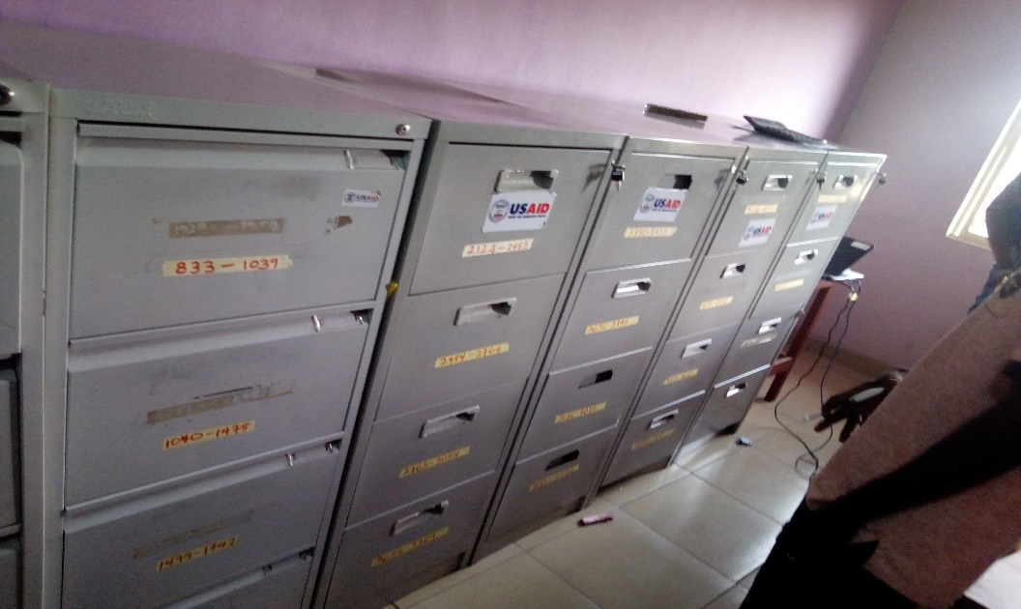**FY 2018 Data Quality Assessment**

nichegem gahia FOR DEVTECH systems, inc. / USAID

Local OVC Partners in Nigeria 1(LOPIN 1)

Association for Reproductive and Family Health (ARFH)

Report Submitted: September 28, 2018

*This page is intentionally left blank.*

**Table of contents**

ACRONYMS 1

1 EXECUTIVE SUMMARY 1

1.1 INTRODUCTION, PURPOSE AND METHODOLOGY 1

1.2 FINDINGS 2

1.3 ACTION PLAN 4

2 Introduction and purpose of the DQA 5

2.1 DATA QUALITY STANDARDS 6

2.2 OBJECTIVES OF THE DQA 6

2.3 INDICATORS ASSESSED 7

2.3.1 OVC_SERV 7

2.3.2 OVC_HIVSTAT 7

2.4 PERIOD OF THE DQA 8

2.5 THE LOPIN 1 ACTIVITY 8

3 METHODOLOGY 10

3.1 SAMPLING METHODOLOGY FOR SITE SELECTION 10

3.1.1 INCLUSION CRITERIA: 10

3.1.2 EXCLUSION CRITERIA: 11

3.2 SAMPLE SIZE 11

3.3 SELECTION OF BENEFICIARY FOLDERS AND FORMS FOR OVC INDICATOR REVIEW AT SITES 12

3.4 DATA COLLECTION FOR VALIDATION OF THE SELECTED INDICATORS 12

3.4.1 M&E SYSTEMS ASSESSMENT 13

3.4.2 DATA VERIFICATION 13

3.4.3 DEFINITION AND INTERPRETATION OF THE VERIFICATION FACTOR 14

3.4.4 METHODOLOGY FOR CROSS-CHECKS AT THE CBO LEVEL 14

3.5 DQA TOOL 15

3.6 OTHER OPERATIONAL CONSIDERATIONS FOR DQAS 16

3.7 DATA ANALYSIS 17

4 FINDINGS 18

4.1 M&E SYSTEMS ASSESSMENT – SIX FUNCTIONAL AREAS 18

4.1.1. LOPIN 1 CENTRAL M&E UNIT 18

4.1.2 LOPIN 1 STATE-LEVEL M&E UNIT 20

4.1.3 LOPIN 1 SERVICE DELIVERY LEVEL (CBOs) 24

4.2 DATA QUALITY STANDARDS 26

4.2.1 VALIDITY 26

4.2.2 RELIABILITY 32

4.2.3 PRECISION 33

4.2.4 TIMELINESS 33

4.2.5 INTEGRITY 34

5 Action plan for LOPIN 1 36

5.1 ACTION PLAN FOR LOPIN 1 central LEVEL 36

5.2 ACTION PLAN FOR LOPIN 1 STATE LEVEL 37

5.3 ACTION PLAN FOR LOPIN 1CBO LEVEL 38

6 Limitations and Constraints 39

7 Conclusions 40

8 Annexes 41

8.1 LIST OF SITES VISITED AND LOCATIONS 41

8.2 STEPS FOR DATA VERIFICATION USING THE MEASURE EVALUATION TOOL 41

8.3 VERIFICATION FACTORS – OVC_SERV LOPIN 1 CENTRAL, STATE AND CBO LEVELS 42

8.5 DIAGRAMMATIC REPRESENTATION OF CROSS-CHECKS AT CBO LEVEL 45

8.6 DATA BACKUP MECHANISMS IN AKWA IBOM STATE CBOs 46

8.7 DATA BACKUP MECHANISMS IN LAGOS STATE CBOS 46

8.8.DATA BACKUP MECHANISMS IN RIVERS STATE CBOs 46

8.9 PERFORMANCE INDICATOR REFERENCE SHEET (PIRS) 47

8.10 LIST OF DOCUMENTS, DATA, AND STANDARD OPERATING PROCEDURES REVIEWED 54

8.10.1 LIST OF LOPIN 1 DATA AND DOCUMENTS REVIEWED 54

8.10.2 LIST OF LOPIN 1 REPORTING TOOLS REVIEWED 54

8.10.3 LOPIN 1 SOP/GUIDELINES AND OTHER DOCUMENTS REVIEWED 54

8.11LIST OF INDIVIDUALS INTERVIEWED DURING THE LOPIN 1 DQA 55

**LIST OF TABLES**

Table 1. Data Quality Standards and Operational Definitions 6

*Table 2. Schedule for LOPIN 1 DQA* 8

Table 3. List of Central, State, and CBO Offices / Sites visited for the LOPIN 1 DQA 11

*Table 4. Data Coverage for LOPIN 1 DQA, by Level* 12

Table 5. Cross-Check Findings from LOPIN 1 CBOs in Lagos, Rivers and Akwa Ibom River States OVC_SERV 31

Table 6. Cross-Check Findings from LOPIN 1 CBOs in Lagos, Rivers and Akwa Ibom River States OVC_HIVSTAT 31

Table 7. Mechanisms for Ensuring Data Integrity Across LOPIN 1 Sites 35

Table 8. Mechanisms for Ensuring Data Integrity Across LOPIN 1 State Offices 35

Table 9. Action Plan for LOPIN 1 Central Level 36

Table 10. Action Plan for LOPIN 1 State Level 37

Table 11. Action Plan for LOPIN 1 CBO-Level 38

Table 12. Verification Factors – OVC_SERV at LOPIN 1 Central M&E Unit 42

Table 13. Verification Factors – OVC_SERV at LOPIN 1 State and CBO Levels 42

Table 14. OVC_HIVSTAT Numerator Disaggregates at the Central, State and CBO Levels 43

Table 15. Verification Factors of OVC_HIVSTAT Numerator Disaggregates at the Central, State and CBO Levels 44

Table 16. Backup Mechanisms Utilized in Akwa Ibom State CBOs Visited 46

Table 17. Backup Mechanisms Utilized in Lagos State CBOs Visited 46

Table 18. Backup Mechanisms Utilized in Rivers State CBOs Visited 46

Table 19: Performance Indicator Reference Sheet for OVC_SERV 47

Table 20: Performance Indicator Reference Sheet for OVC_HIVSTAT 50

Table 21. List of Individuals Interviewed during the LOPIN 1 DQA 55

**LIST OF FIGURES**

Figure 1. Data Management System Assessment – Global Average for all LOPIN 1 Sites Assessed 3

*Figure 2. Spider Graph of M&E Systems Assessment: LOPIN 1 Central M&E Unit* 19

Figure 3. Spider Graph of M&E Systems Assessment: LOPIN 1 State-Level, Akwa Ibom State 22

Figure 4. Spider Graph of M&E Systems Assessment: LOPIN 1 State-Level, Lagos State 22

*Figure 5. Spider Graph of M&E Systems Assessment: LOPIN 1 State-Level, Rivers State* 23

Figure 6. Indictor 1: OVC_SERV Data Verification by level of reporting system 28

Figure 7: OVC_HIVSTAT Data Verification Factors by level of reporting system for LOPIN 1 29

Figure 8: OVC_HIVSTAT Data Verification Factors for Numerator Disaggregate at the LOPIN 1 States 29

Figure 9: OVC_HIVSTAT Data Verification Factors for Numerator Total at the LOPIN 1 CBOs 30

Figure 10. Verification Factors for LOPIN 1 Akwa Ibom, Lagos and Rivers States and CBOs 32

Figure 11. Reporting Performance – Results for LOPIN 1 States 34

*Figure 12. Tracing and Verifying Reported Totals: CBO via State to Central M&E Unit* 41

*Figure 13. Methodology for Cross-Checks at CBO Level* 45

# ACRONYMS

ADS Automated Directives System (USAID)

AMELP Activity Monitoring, Evaluation and Learning Plan

AOCF Arms of Comfort Foundation

APO Assistant Program Officer

ARFH Association for Reproductive and Family Health

BF BROKLINE Foundation

CBO Community Based Organization

CEO Chief Executive Officer

CF Chamange Foundation

CMP Change Management Process

CV Community Volunteers

DATIM Data for Accountability, Transparency and Impact

DEC Data Entry Clerk

DQA Data Quality Assessment

DQA Data Quality Audit

DSD Direct Service Delivery

HCF Hope and Care Foundation

HIV Human Immunodeficiency Virus

HIV/AIDS Human Immunodeficiency Virus / Acquired Immunodeficiency Syndrome

IM Implementing Mechanism

IP Implementing Partner

LCIF Lifetime Caring International Foundation

LGA Local Government Authority (or Area)

LOPIN Local Orphans and Vulnerable Children (OVC) Partners in Nigeria

LTFU Lost to Follow Up

M&E Monitoring and Evaluation

MEL Monitoring, Evaluation, and Learning

MER Monitoring, Evaluation, and Reporting

MWASD Ministry of Women’s Affairs and Social Development

NOMIS National OVC Management Information System

OGAC Office of the United States Global AIDS Coordinator

OVC Orphans and Vulnerable Children

OVC_HIVSTAT PEPFAR Indicator: Number of children less than 18 years with reported HIV status to implementing partner

OVC_SERV PEPFAR Indicator: Number of beneficiaries served by PEPFAR OVC programs for children and families affected by HIV

PEPFAR President’s Emergency Plan for AIDS Relief

PIRS Performance Indicator Reference Sheet

PM Program Manager

RDQA Routine Data Quality Assessment

RHN Rhoda Haven Network for Women Living with HIV/AIDS

RIDEC Rhemacare Integrated Development Centre

SAPR Semi-Annual Program Results

SIDHAS Strengthening Integrated Delivery of HIV/AIDS Services

SMILE Sustainable Mechanism for Improving Livelihoods and Household Empowerment

SMWASD State Ministry of Women Affairs and Social Development

SOP Standard Operating Procedures

SRH Sexual and Reproductive Health

STEER Systems Transformed for Empowered Action and Enabling Responses for Vulnerable Children and Families

USAID United States Agency for International Development

VC Vulnerable Children

# EXECUTIVE SUMMARY

## 1.1 INTRODUCTION, PURPOSE AND METHODOLOGY

The United States Agency for International Development (USAID)/Nigeria technical offices regularly collect performance data from their Implementing Partners (IPs), and analyze it to make management decisions. Program management requires accurate, reliable, complete, and timely data to facilitate evidence-based decision making. Orphan and Vulnerable Children (OVC) programs among Human Immunodeficiency Virus, Acquired Immunodeficiency Syndrome (HIV/AIDS) affected populations provide need-based and age-appropriate socioeconomic interventions and require data that ensures provision of high-quality services. Since poor-quality data affect conclusions about performance and lead to incorrect decisions, USAID requires that all Missions/Offices conduct regular Data Quality Assessments (DQA), to review (1) strengths and weaknesses of the data, as determined by applying the five data quality standards (i.e., ***validity, reliability, timeliness, precision and integrity***); and (2) the extent to which the data integrity can be trusted in making management decisions.

The Local OVC Partners in Nigeria 1 (LOPIN 1) Activity is one of the USAID/Nigeria’s OVC Implementing Mechanisms (IMs) being implemented by the Association for Reproductive and Family Health (ARFH). In June 2018, USAID/Nigeria and the Monitoring, Evaluation, and Learning (MEL) Activity of DevTech Systems, Inc. conducted a joint DQA exercise to review the performance data submitted by ARFH LOPIN 1 to USAID for the period October 1, 2017 to March 2018 for two President’s Emergency Plan for AIDS Relief (PEPFAR) indicators, “OVC_SERV” and “OVC_HIVSTAT.” OVC_SERV is the “number of beneficiaries served by PEPFAR OVC programs for children and families affected by HIV” and OVC_HIVSTAT is the “percentage of OVC (less than 18 years old) with HIV status reported to IP (including status not reported), disaggregated by status type.” The denominator is no longer collected as part of the OVC_HIVSTAT indicator. The denominator is collected as part of the OVC_SERV indicator.

The DQA was implemented using a purposive sampling methodology in eight selected Community Based Organizations (CBOs) in Akwa Ibom, Lagos and Rivers states, the respective ARFH state offices, and the ARFH central Monitoring and Evaluation (M&E) Unit. The ARFH central M&E unit has physical presence in Oyo state, but the assessment was conducted in Lagos state for logistical convenience.

The DQA methodology at all levels included: (1) A review of the activity M&E documents, materials, and data, including Standard Operating Procedures (SOP), guidelines, the Performance Indicator Reference Sheet (PIRS), and other guiding documents for organizational M&E management, data management, and processing; (2) A review of six months of LOPIN 1 OVC summary reports, and trace and verification of data for the two indicators (including Nigeria OVC Management Information System [NOMIS] data); (3) A review of a subset of source documents (beneficiary forms and household folders), and entries of beneficiaries and households data in the NOMIS; (4) Interviews with M&E officers and personnel; (5) cross-checks across systems and records; (6) A review of the data applying the five data quality standards (i.e., validity, reliability, integrity, precision and timeliness); and (7) A debrief at each site on the preliminary DQA findings using a feedback form. The DQA team utilized the USAID MEASURE Evaluation’s DQA Excel Tool (RDQA multi-indicator version[1]), as well as the USAID DQA checklist[2] to assess the data quality standards.

## 1.2 FINDINGS

**M&E Systems Assessment**

LOPIN 1 Central M&E Unit: *Strengths*: (1) Clear responsibilities for the review of data at the central level assigned to the Senior M&E Officer and M&E Director; (2) Availability and use of an M&E Manual for LOPIN Region 1; (3) Use of the NOMIS to report data; (4) Availability of trained M&E staff; (5) Engagement of ad-hoc staff as monitors to help with data quality checks; and (6) Data are being analyzed and used to inform activity implementation. *Areas for Improvement*: (1) The LOPIN 1 Data Management SOP does not include a section on Change Management Process (CMP); and (2) The data generated by the current version of NOMIS at the LOPIN 1 Headquarters (HQ) office did not tally with the data reported for Fiscal Year (FY) 2018 Semi Annual Progress Results (SAPR). *Recommendations*: (1) Update the LOPIN 1 Data Management SOP to include section on CMP to guide reporting of data updates; and (2) Update NOMIS software to the most recent version to address NOMIS data discrepancies.

LOPIN 1 State M&E Units: *Strengths*: (1) All state-level M&E Officers reported to have received relevant training to carry out their assigned responsibilities; (2) Availability of PIRS for the two indicators assessed and an SOP to guide activity implementation; and (3) Use of data for decision making. *Areas for Improvements:* (1) Lack of guidelines on CMPs; (2) Late submission of reports by CBOs in Akwa Ibom state; (3) Activity data not consistently backed up in Akwa Ibom state; and (4) No written procedure(s) to address incomplete, late, inaccurate and follow-up with CBOs on data quality issues in Akwa Ibom and Lagos states. *Recommendations:* (1) Develop a CMP to guide reporting of data updates; (2) Ensure CBO compliance to reporting deadlines (Akwa Ibom state); (3) Ensure compliance to data back-up guidelines (Akwa Ibom state); and (4) Develop written guidelines to inform steps to be taken to address incomplete, late and inaccurate data reporting by CBOs.

LOPIN 1 CBOs: *Strengths*: (1) Several mechanisms are in place to ensure the confidentiality of beneficiary records and to minimize data quality issues; (2) A suitable backstop is available to fill in for the M&E Officer when not available; (3) Availability and use of PIRS and SOPs to guide activity implementation; (4) Good filing and storage systems observed at all the CBOs visited; and (5) Data are analyzed and used to inform activity implementation. *Areas for Improvement:* (1) No CMP to guide reporting of data updates at Lifetime Caring International Foundation (LICF), Hope and Care Foundation (HCF) and Rhemacare Integrated development Centre (RIDEC); (2) Stock out of Volunteer Counsellor (VC) service forms at Arms of Comfort Foundation (AOCF) and use of outdated service forms (HCF); (3) Service forms not accurately and completely filled by Community Volunteers (CVs) at BROKLINE Foundation (BF), HCF and AOCF; and (4) Old computers with inadequate capacity for large data are in use, making data entry slow (BF). *Recommendations:* (1) Utilize CMP guidelines to report data updates; (2) Conduct refresher training for CVs on the completion of data tools (BF, AOCF and HCF); (3) Provide updated service forms to AOCF and HCF and discourage the use of outdated service forms; (4) Upgrade computer software to a higher capacity or procure a computer with capacity for large data, to improve the process of data entry into the NOMIS (BF).

The general findings on the M&E systems assessment for all levels assessed are shown in the spiderweb graph in Figure 1.The areas for improvement for the LOPIN 1 IM are in data management processes and links with the national reporting system, which occurred because of parallel reporting channels i.e., to government and donor agencies. However, there are mechanisms in place to harmonize data at the different levels such as periodic state and national level data harmonization meetings.

Figure 1. Data Management System Assessment – Global Average for all LOPIN 1 Sites Assessed

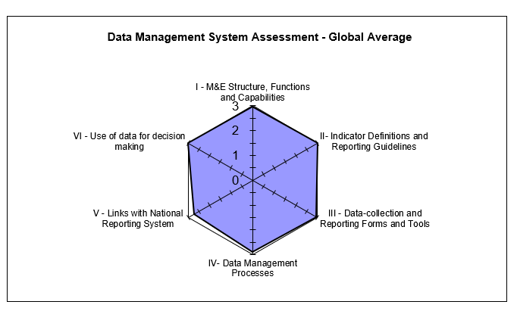

**Data Quality Standards**

Validity*:* *Strengths:* (1) The data collection process adheres to PIRS requirements; and (2) The data were reported for the two indicators assessed: (a) beneficiaries served (OVC and family members); and (b) vulnerable children less than 18 years disaggregated by their HIV status. This remained consistent across all CBOs. *Areas for Improvement:* (1) Transcription errors observed from incomplete entries into the source documents and into the NOMIS, which led to both under and over reporting; (2) Errors observed during data verification due to under-reported or over-reported data at three CBOs (BF, AOCF and Chamagne Foundation [CF]); and (3) Missing data in the NOMIS after data export and following the NOMIS software upgrade. *Recommendations:* (1) Improve supervisory efforts with the CBOs to ensure accurate data entry and proper use of the NOMIS; (2) Provide refresher training on the NOMIS software to Data Entry Clerks (DEC); (3) CBO M&E Officers should conduct periodic folder audits to resolve discrepancies observed during cross checks; (4) Update the NOMIS software to the most recent version to address NOMIS data discrepancies; and (5) Develop clear guidelines for the CBOs on data CMP and documentation, to resolve discrepancies in data reported after the reporting deadline.

Reliability*:* *Strengths*: National OVC reporting tools were consistently used during the reporting period. *Areas for Improvement:* (1) Stock out of OVC service forms at AOCF; and (2) Use of old Vulnerable Children (VC) service form at HCF. *Recommendations:* (1) Provide adequate stock of reporting tools at all CBOs (especially at AOCF); and (2) Ensure all CBOs are using the most updated version of reporting tools and discourage the use of outdated tools (especially at HCF).

Precision*:* *Strengths*: Data from service forms are entered in the NOMIS in a consistent manner, including using all nationally approved data fields. The NOMIS has individual-level data, providing sufficient detail and precision on the two indicators assessed. *Areas for Improvement:* None. *Recommendations:* There were no specific recommendations in connection with data precision.

Timeliness*:* *Strengths*: Reporting from CBO level upward is electronic and through the NOMIS and was reported to have been received in a timely manner at the higher levels except for some reports from CBOs in Akwa Ibom state that were not timely reported. The aggregated reporting rate for the three states was 89 percent. *Areas for Improvement:* Late reporting by CBOs in Akwa Ibom state. *Recommendations:* Ensure CBOs’ compliance to reporting timelines (especially at LOPIN 1 Akwa Ibom state CBOs).

Integrity*:* *Strengths:* (1) Data quality assurance and management at the central and state levels is through the NOMIS, which has password access for confidentiality, and built-in error and quality checks; (2) Data review meetings are held periodically during which data quality issues are discussed; and (3) Internal DQAs are conducted periodically. *Areas for Improvement*: (1) Several corrections on OVC service dates were observed on the service forms at CBOs in Akwa Ibom state; (2) Data quality cross check of NOMIS data with an Excel hard copy of the exported data was observed at only one CBO. *Recommendations:* (1) Provide refresher training for CBO staff on how to fill data collection tools; and (2) Ensure all CBOs conduct data quality cross checks of NOMIS electronic data with an Excel hard copy containing exported data before reporting to the next level.

## 1.3 ACTION PLAN

*Central Level:* (1) Update the NOMIS software to the most recent version to address NOMIS data discrepancies; (2) Update the LOPIN 1 Data Management SOP to include section on CMP to guide reporting of data updates; (3) Update the LOPIN 1 Data Management SOP to include a section that addresses incomplete, late, inaccurate reporting and feedback to lower reporting levels; and (4) Disseminate the updated SOP to lower reporting levels and ensure usage compliance.

*State Level*: (1) Improve supervisory efforts with the CBOs to ensure accurate data entry and proper use of the NOMIS; (2) Conduct refresher training for DECs on the NOMIS software; (3) Ensure all CBOs conduct data quality cross checks between NOMIS soft copy data and a hard copy Excel NOMIS data before reporting; (4) Provide support to CBO M&E Officers to conduct periodic folder audits to resolve discrepancies observed during cross checks; (5) Update NOMIS with the latest version of the software to prevent data loss following data export; (6) Ensure compliance of CBOs in Akwa Ibom state to reporting timelines; (7) Ensure compliance to data back-up guidelines in Akwa Ibom state; (8) Conduct refresher training for CVs on the completion of data tools (BF, AOCF and HCF); (9) Ensure adequate supply of updated reporting tools to all CBOs (especially AOCF); (10) Ensure CBO compliance to usage of only updated reporting tools; and (10) Conduct capacity building for CBOs on proper filing of source documents (HCF).

*CBO Level:* (1) Upgrade computer software to a higher capacity or procure a computer with capacity for large data, to improve the process of data entry into the NOMIS (BF); (2) Improve supervisory efforts with the CVs and DECs to ensure completeness and accurate data entry into the service forms and into the NOMIS; and (3) Conduct regular folder audits to resolve discrepancies observed during cross checks.

# Introduction and purpose of the DQA

The United States Agency for International Development (USAID)/Nigeria technical offices regularly collect performance data from their Implementing Partners (IPs), and analyze it to make management decisions. Program management requires accurate, reliable, complete, and timely data to facilitate evidence-based decision-making and, ultimately, to ensure efficient and effective program implementation. Orphan and Vulnerable Children (OVC) programs among populations affected by Human Immunodeficiency Virus, Acquired Immunodeficiency Syndrome (HIV/AIDS) provide socioeconomic interventions that are need based and age appropriate, and therefore require data to ensure that high-quality services are provided to children and their families. This is even more important in households with an HIV-positive child or caregiver, who will need to receive the appropriate support to access care, treatment, and other related services. Since poor-quality data could affect conclusions about performance and lead to incorrect decisions, USAID requires that all Missions/Offices conduct regular Data Quality Assessments (DQA).

The Automated Directives System (ADS) contains the organization and functions of USAID, along with the policies and procedures that guide the Agency's programs and operations. As shown in ADS 201, the purpose of a DQA is to ensure that USAID Missions are aware of the:

1. Strengths and weaknesses of the data, as determined by applying the five data quality standards (Table 1 below); and
2. Extent to which the data integrity can be trusted in making management decisions (ADS 201.3.5.8).

One of the primary purposes of the DQA described in this report is to meet the ADS-related requirements of USAID/Washington and the USAID/Nigeria technical offices. A DQA also serves to review the Monitoring and Evaluation (M&E) system, identify best practices, and develop recommendations to improve existing systems, for better reporting of activity level indicators in subsequent funding cycles.

The President’s Emergency Plan for AIDS Relief (PEPFAR) Nigeria implements its OVC activities through community-based partners and, in some cases, through comprehensive treatment partners who provide some OVC services. Most OVC IMs work through Community-Based Organizations (CBOs) that work directly with the communities although in some cases IPs conduct direct implementation to beneficiaries. Performance results are reported semi-annually based on the Office of the Global AIDS Coordinator (OGAC) requirements, and quarterly based on USAID requirements.

A joint DQA was conducted in the month of June 2018 by USAID/Nigeria and the Monitoring, Evaluation and Learning (MEL) Activity of DevTech Systems, Inc., to validate six months of performance data generated through the Local OVC Partners in Nigeria 1 (LOPIN 1) Activity implemented by the Association for Reproductive Health (ARFH), one of USAID/Nigeria’s OVC Implementing Mechanisms (IM). The DQA was for the “OVC_SERV” and “OVC_HIVSTAT” PEPFAR indicators, as reported through the National OVC Management Information System (NOMIS) between October 1, 2017 and March 31, 2018. The LOPIN 1 DQA was conducted at the central IP office (Lagos state was used a proxy for convenience), three state offices and eight selected CBOs; two in Akwa Ibom state, three in Lagos state and three in Rivers state, with guidance from USAID and using purposive sampling methodology.

## 2.1 DATA QUALITY STANDARDS

Table 1 lists the five data quality standards that are central to a DQA, especially in the context of USAID-funded activities.

Table 1. Data Quality Standards and Operational Definitions

|  |  |
| --- | --- |
| Data Quality Standard | Operational Definition |
| Validity | Data are valid to the extent that they clearly, directly and adequately represent the result that was intended to be measured. Measurement errors, unrepresentative sampling and simple transcription errors may adversely affect data validity. Data should be periodically tested to ensure that no error creates significant bias. |
| Reliability | Data reflect stable and consistent data collection processes and analysis methods over time. Activity/Project managers are confident that progress toward performance targets reflects real changes rather than variations in data collection methods. Reliability can be affected by questionable validity as well as by changes in data collection processes. |
| Timeliness | Data are available with enough frequency and should be sufficiently current to inform management decision-making. Effective management decisions depend upon regular collection of up-to-date performance information. |
| Precision | Data should be sufficiently accurate to present a fair picture of performance and enable project managers to make confident decisions. |
| Integrity | Data that are collected, analyzed and reported should have a mechanism in place to reduce the possibility that data are subject to erroneous or intentional alteration. |

Source: ADS 201. Data Quality Assessment Standards.

## 2.2 OBJECTIVES OF THE DQA

In addition to the overall purpose of the DQA mentioned in ADS 201, the specific objectives of the DQA are to:

1. Verify that the quality of data reported from October 1, 2017 to March 31, 2018 for the OVC_SERV and OVC_HIVSTAT indicators, by the LOPIN 1 Activity (section 0, page 8), are grounded in the components of data quality.
2. Ensure that managers can use data generated to effectively direct available resources, and to evaluate progress toward established goals.
3. Assess and identify potential challenges to data quality created by the data management and reporting systems at three levels:

* The Activity’s Central M&E Unit;
* The Intermediary Aggregation level (IP state office); and
* The Service Delivery level (CBO office in the Local Government Area [LGA]).

1. Develop action plans to improve weaknesses identified in the levels above.

## 2.3 INDICATORS ASSESSED

The selection of the indicators for assessment was based on technical guidance from USAID/Nigeria. The indicators assessed during this DQA exercise are the OVC_SERV and OVC_HIVSTAT.

### 2.3.1 OVC_SERV

The OVC_SERV indicator is defined according to the PEPFAR Monitoring, Evaluation and Reporting (MER) 2.0 Indicator Reference Guide Version 2.2 as the **“number of beneficiaries served by PEPFAR OVC programs for children and families affected by HIV.”** It was recently revised in the PEPFAR MER Version 2.2 guide to exclude from the calculation, beneficiaries who transferred and exited out of the activity without graduation.

For a specific reporting period, the indicator is generated by totaling the number of “active beneficiaries” who received at least one service in the past three months and beneficiaries who successfully graduated from the PEPFAR OVC activity.

“Active Beneficiaries” = (Last reporting period’s Active + Newly enrolled in current reporting period) minus (Current reporting period’s graduated + Transferred + Exited)

The Performance Indicator Reference Sheet (PIRS) for the indicator defines its dimensions and description (Annex section 8.9, Table 19). This indicator is calculated from data elements in the NOMIS.

Disaggregation: The indicator, by disaggregating “active” and “graduated,” measures how successful the OVC activity is building the resiliency of children and their families.

Data Sources: OVC activity enrollment form, service forms, registers and activity data that are generated by IPs from NOMIS. IPs need to record the names of children and caregivers who meet the criteria for “active beneficiary” and “graduated to generate the number that this indicator foresees.

Reporting Level for the indicator includes site level and community, and the reporting timeframe is semi-annually.

### 2.3.2 OVC_HIVSTAT

The OVC_HIVSTAT indicator is defined according to the PEPFAR MER 2.0 Indicator Reference Guide Version 2.2. as the **“percentage of orphans and vulnerable children (less than 18 years old) with HIV status reported to implementing partners (including report of no status).”** This indicator formerly called OVC_ACC (MER1.0) and OVC_KNOWSTAT (in the original MER 2.0 target setting documentation guidance) was changed to OVC_HIVSTAT to reflect that HIV is self-reported to the IP by the OVC or OVC caregiver (MER 1.0 to MER 2.0). The PIRS for the indicator defines its dimensions and description (Annex section 8.9, Table 20). This indicator is calculated from data elements in the NOMIS.

Numerator: Number of orphans and vulnerable children (less than 18 years old) with HIV status reported to implementing partner, disaggregated by status type.

Denominator: This is not collected again as part of the indicator but is collected under the indicator OVC_SERV. It is the number of OVC reported under OVC_SERV (less than 18 years old).

Disaggregation:

* Reported as HIV positive to the IP
* Currently receiving Anti-Retroviral Therapy (ART) and;
* Not currently receiving ART.
* Reported as HIV negative to IP; and
* Reported with no HIV infection to the IP
* HIV test not indicated based on HIV risk assessment; and
* Other reasons.

Data Sources for the indicator include the vulnerable children enrollment form, vulnerable children service form, vulnerable children follow-up form, HIV test results that are self-reported by the OVC, registers and activity data generated by IPs. All the forms have the names of children and their HIV status to generate the number included in this indicator.

Reporting Level for the indicator includes site level, facility and community, and the reporting timeframe is semi-annual.

## 2.4 PERIOD OF THE DQA

The DQA covered the USAID SAPR period, which comprises two quarters—i.e., October 1, 2017 to December 31, 2017, and January 1, 2018 to March 31, 2018. The schedule for the DQA is shown in Table 2 below.

*Table 2. Schedule for LOPIN 1 DQA*

|  |  |  |
| --- | --- | --- |
| IM | Level | Date of DQA |
| LOPIN 1 | Central Level DQA | June 25, 2018 |
| Aggregation and service delivery levels in Akwa Ibom State | June 27, 2018 |
| Aggregation and service delivery levels in Lagos State | June 11-14, 2018 |
| Aggregation and service delivery levels in Rivers state | June 28-29, 2018 |

## 2.5 THE LOPIN 1 ACTIVITY

ARFH is a national, non-governmental organization established in 1989 and registered in 1991. The headquarters is in Ibadan, Oyo state, with three other offices in Abuja, Kaduna and Katsina states. The mission is to initiate, promote and implement in partnership with other organizations, developmental, HIV&AIDS, Sexual Reproductive Health (SRH) and family planning activities and interventions for young people and adults through capacity building, technical assistance, operations research and evaluation to improve the quality of life in Nigeria and elsewhere in Africa.

USAID/Nigeria awarded ARFH with the LOPIN 1 Activity in 2014. The five-year activity (August 2014 to August 2019) aims to mitigate the impact of HIV/AIDS and other forms of vulnerability on children and their households. The LOPIN 1 Activity, which is implemented across three states (Akwa Ibom, Lagos and Rivers) and 17 LGAs (six LGAs in Akwa Ibom state, seven LGAs in Lagos state and four LGAs in Rivers state) is designed to model inclusiveness in programming for OVC in accordance with the National Priority Agenda. Apart from providing services to beneficiaries, LOPIN 1 also focuses on strengthening stakeholders’ capacity to provide services as well as strengthening public private partnership.

As of March 2018, 139,658 OVC and caregivers had been served out of which 97,675 were OVC less than 18 years with HIV status reported to LOPIN 1.

# METHODOLOGY

The DQA methodology included the following steps:

1. Desk review of project documents, materials, and data, including:

* The organization’s SOP, guidelines, PIRS for the indicator, and other guidance documents for organizational M&E management, data management, and processing;
* Six months (October 1, 2017 to March 31, 2018) of LOPIN 1 performance data for the PEPFAR indicators “OVC_SERV” and “OVC_HIVSTAT” as calculated using data elements within the NOMIS;
* State-level summary reports for the reporting period defined above; and
* Entries of beneficiaries and their households in the NOMIS.

2. Key informant interviews (KIIs) and focus group discussions (FGDs) with members of the LOPIN 1 M&E team at all levels. Since only one M&E focal person or staff was usually available in the field, the majority of the M&E systems assessments were conducted as KIIs.

3. Trace and verification of reported data with cross-checks across systems and records, including review of beneficiary folders and service forms.

4. Review and application of the five data quality standards (validity, reliability, integrity, precision and timeliness).

## 3.1 SAMPLING METHODOLOGY FOR SITE SELECTION

A purposive sampling technique was used for the selection of DQA sites. This was based on USAID/Nigeria’s guidance and also based on the fact that the DQAs for six OVC IMs were concurrently implemented during the period of the exercise: LOPIN 1, STEER (Systems Transformed for Empowered Action and Enabling Responses), SMILE (Sustainable Mechanism for Improving Livelihoods and Household Empowerment), LOPIN 3 (Local OVC Partners in Nigeria 3), LOPIN 2 (Local OVC Partners in Nigeria 2), and SIDHAS (Strengthening Integrated Delivery of HIV/AIDS Services). All together, these six IM implement OVC activities in 22 Nigerian states, across 235 LGAs.

The selection criteria used are detailed below:

### 3.1.1 INCLUSION CRITERIA:

* LGAs where USAID-supported OVC activities are actively being implemented by LOPIN 1;
* LGAs which reported results for the OVC_SERV and OVC_HIVSTAT indicators for FY 2018 SAPR (October 1, 2017-March 31, 2018); and
* LGAs visited or within close proximity to those visited during the USAID/Nigeria FY 2017 DQA exercise for the OVC_SERV indicator for the STEER, SMILE and LOPIN 3 IMs.

### 

### 3.1.2 EXCLUSION CRITERIA:

* Sites located in high security level states, ranked at level four or for which access to the state requires passage through a level four state; and
* Sites located in a difficult, hard to reach terrain.

## 3.2 SAMPLE SIZE

The IP’s central office, three IP state offices (Akwa Ibom, Lagos and Rivers) and eight CBOs (service delivery sites) were selected based on the criteria outlined above and visited for the DQA exercise. Table 3 below provides the complete list of sites selected and visited for the DQA exercise.

Table 3. List of Central, State, and CBO Offices / Sites visited for the LOPIN 1 DQA

|  |  |  |  |  |
| --- | --- | --- | --- | --- |
| S. No | Level | Name of Office / Site | State/LGA | Date of visit |
| 1 | LOPIN 1Central M&E Unit | LOPIN 1 central office | Lagos (used as proxy for the Oyo HQ office) | 25 June 2018 |
| 2 | Aggregation level | LOPIN 1 state office | Akwa Ibom | 27 June 2018 |
| 3 | Service delivery level | Heal the Land Initiative (HELIN) | Akwa Ibom/Uyo | 27 June 2018 |
| 4 | Service delivery level | BROKLINE Foundation (BF) | Akwa Ibom/Ikot Ekpene | 27 June 2018 |
| 5 | Aggregation level | LOPIN 1 state office | Lagos | 11 June 2018 |
| 6 | Service delivery level | Chamagne Foundation (CF) | Lagos/Agege | 11 June 2018 |
| 7 | Service delivery level | Rhoda Haven Network for Women Living with HIV/AIDS (RHN) | Lagos/Ajeromi Ifelodun | 11 June 2018 |
| 8 | Service delivery level | Arms of Comfort Foundation (AOCF) | Lagos/Kosofe | 14 June 2018 |
| 9 | Aggregation level | LOPIN 1 state office | Rivers | 28 June 2018 |
| 10 | Service delivery level | Lifetime Caring International Foundation (LCIF) | Rivers/Eleme | 28 June 2018 |
| 11 | Service delivery level | Rhemacare Integrated Development Centre (RIDEC) | Rivers/Obio Akpor | 28 June 2018 |
| 12 | Service delivery level | Hope and Care Foundation (HCF) | Rivers/Port Harcourt | 29 June 2018 |

Staff with OVC M&E responsibilities were interviewed for the M&E systems assessment across the three levels. For convenience, Lagos state was used as a proxy for the central M&E unit assessment, hence the LOPIN 1 M&E Director and other central M&E unit staff, stationed in Oyo state, travelled to Lagos state for the assessment. A complete list of a personnel interviewed at various levels is provided in Annex section 01, Table 21. From the perspective of DQA coverage for data verification, a major strength was that 100 percent of aggregate data records were reviewed at the central, state, and CBO levels (Table 4).

*Table 4. Data Coverage for LOPIN 1 DQA, by Level*

|  |  |  |
| --- | --- | --- |
| Data Coverage for LOPIN 1 OVC DQA, by Level | | |
| Level / Location | **Data Format(s)** | **Sample Covered for Data Verification** |
| Central M&E Unit | Electronic (NOMIS) | All records / 100% |
| Three IP State Offices (Akwa Ibom, Lagos and Rivers states) | Electronic (NOMIS) | All records / 100% |
| Service Delivery Level / CBO | Electronic (NOMIS) | All records / 100% |
| Service Delivery Level (Cross-Checks on Source Documents) | Electronic (NOMIS) and Paper (Beneficiary Forms and Folders) | 20 per CBO:  10 forward cross-checks – folder/form to NOMIS, and  10 reverse cross-checks – NOMIS to folder/form.  The average number of eligible forms reviewed per folder was about 5. |

## 3.3 SELECTION OF BENEFICIARY FOLDERS AND FORMS FOR OVC INDICATOR REVIEW AT SITES

To ensure adequate time for the DQA team to complete all aspects of the DQA—including the M&E systems assessment, review of the data quality standards, data verifications, and cross-checks—the DQA team reviewed at least ten beneficiary folders (randomly selected, where feasible) for the service period between October 1, 2017 to March 31, 2018. All of the beneficiaries in each of the ten service folders who have received at least one service within the review period and which are less than 18 years of age were selected for cross-checks between the beneficiary service forms and the NOMIS. It must be noted that an OVC beneficiary household folder often contains more than one beneficiary service form. A beneficiary can be served multiple times in a span of six months, and there may be more than one eligible beneficiary per household. An additional ten unique beneficiary records from the NOMIS were traced back to the beneficiary folders for further cross-verification.

Indicator 1 (OVC_SERV): all the beneficiaries (OVC and family members) in each beneficiary folder are selected for the cross-checks between beneficiary forms and NOMIS.

Indicator 2 (OVC_HIVSTAT): all the beneficiaries in each beneficiary folder that are less than 18 years are selected for cross-checks between the beneficiary forms and the NOMIS.

Details of the methodology for sampling (including random selection) and cross-checks are provided in Figure 13 in the Annex Section.

## 3.4 DATA COLLECTION FOR VALIDATION OF THE SELECTED INDICATORS

Three processes were utilized to collect data for validation of the OVC_SERV and OVC_HIVSTAT indicators reported by LOPIN 1. They include:

1. An M&E systems assessment, administered at each level of the data collection and reporting system, i.e., central M&E unit, state level, and CBOs (service delivery level);
2. Verification of reported data for the OVC_SERV and OVC_HIVSTAT indicators; and
3. Review of the five data quality standards (validity, reliability, integrity, precision and timeliness).

### 3.4.1 M&E SYSTEMS ASSESSMENT

The M&E systems assessment evaluated the data management and reporting system, including an off-site review of documents provided by LOPIN 1, and an on-site follow-up assessment at the LOPIN 1 central M&E unit, three state IP offices and selected CBOs.

### 3.4.2 DATA VERIFICATION

At the central IP level, the DQA team reviewed documents for availability, timeliness, and the completeness of the expected reports from the aggregate levels/IP state offices for the selected reporting period.

At the intermediate/IP state offices, the DQA team carried out the following steps to verify the data:

1. Document review: The DQA team reviewed availability, timeliness, and completeness of expected reports from service delivery sites for the selected reporting period.
2. Verifying reported numbers: To verify reported numbers, the DQA team:
   1. Re-aggregated the numbers submitted by the service delivery sites;
   2. Compared the verified counts to the numbers submitted to the next level (central IP M&E unit); and
   3. Identified reasons for any differences.

The data verification at the service delivery level/CBO sites involved the following processes:

1. Observation and description: This process involved the DQA team’s observation and description of the connection between the delivery of OVC services and the completion of the source document (beneficiary form) to record the HIV status of beneficiaries.
2. Review of source documents: The DQA team reviewed the availability and completeness of the OVC_SERV and OVC_HIVSTAT indicator source documents. At least 20 beneficiary records (randomly selected where feasible) for the selected reporting period were reviewed for the record of their HIV status.
3. Recounting reported results: This involved:
4. Reported numbers of OVC served and OVC less than age 18 with their HIV status reported to LOPIN 1 were recounted from available source documents (beneficiary forms);
5. The above numbers were compared and verified with the figures for OVC served and OVC less than age 18 with reported HIV status from the NOMIS for the period of review (October 1, 2017 to March 31, 2018); and
6. Reasons for any differences were identified and probed to determine if the differences were related to or impacted data quality standards.
7. Cross-checks were performed from beneficiary forms to the corresponding NOMIS entries, and vice versa. Spot checks were not carried out to verify the actual delivery of OVC services to the target population in order to protect beneficiary confidentiality.

During the data verification, LOPIN 1-reported results on the NOMIS for OVC_SERV and OVC_HIVSTAT indicators for each CBO from October 1, 2017 to March 31, 2018 were captured using a Microsoft Excel template. At each CBO, DQA assessors reviewed relevant registers, folders and summary forms to verify the quality of data and to generate actual achievement for the indicator.

### 3.4.3 DEFINITION AND INTERPRETATION OF THE VERIFICATION FACTOR

#### 3.4.3.1 DEFINITION OF VERIFICATION FACTOR

For a specific site, the verification factor is the ratio of verified count (recounted by the DQA team from source documents) to the reported count (from the summary report prepared by the site) for a specific reporting period. It is usually expressed as a percentage. Mathematically, it can be expressed as:

Verification Factor = (Verified count at selected site / Reported count at selected site) x 100

#### 3.4.3.2 INTERPRETATION OF THE VERIFICATION FACTOR

Verification factors greater than 100 percent indicate under-reporting (i.e., the source documents show a higher actual count than the numbers reported in the site summary), while verification factors less than 100 percent indicate over-reporting (i.e., the source documents show a lower actual count than the numbers reported in the summary). Both of these scenarios indicate a validity issue for data quality. A variance of less than ten percent in either direction is usually considered a minor issue. However, from the donor/funding perspective, under-reporting leads to underestimation of the impact of the activity, while systematically high levels of over-reporting not due to errors can lead to questions about the accuracy of the data reporting system.

### 3.4.4 METHODOLOGY FOR CROSS-CHECKS AT THE CBO LEVEL

Cross-checks were performed between beneficiary folders and the NOMIS in two directions:

Cross-check A: From beneficiary folders and corresponding beneficiary service forms to the NOMIS; and

Cross-check B: From the NOMIS to beneficiary folders and corresponding beneficiary service forms.

The DQA team sampled beneficiary folders (randomly selected where feasible) to ensure adequate representation of the complete data available, with a minimum of ten folders selected, and adifferent set of beneficiary folders for each direction of cross-checks. Depending on the total number of folders at the CBO, at a minimum every **n**th folder was selected (where **n**=total number of folders divided by ten). The details of the cross-check methodology are provided below.

#### 3.4.4.1 Cross-check A: From beneficiary folders (and beneficiary service forms) to NOMIS

* Using the selection methodology described above, the DQA team selected at least ten beneficiary folders containing five or more corresponding beneficiary service forms with unique identifiers and enrollment numbers for an OVC service provided in the reporting period.
* The team confirmed that each of the five or more service forms were complete in the ten folders, indicating HIV status of the OVC served in the reporting period and the OVC service provided**.** If any of the forms were incomplete, the relevant details were noted.
* Using the identifying enrollment number/unique identifier on the service form, the beneficiary was traced in the NOMIS to confirm if the corresponding entry existed, and if the basic details (i.e., ID, age, sex, etc.) were correct.

#### 3.4.4.2 Cross-check B: From NOMIS to beneficiary service form

* Using the sampling methodology described earlier (including random selection where feasible), the DQA team selected a different set of at least ten unique identifiers and enrollment numbers for OVC less than age 18 served in the NOMIS for the reporting period.
* Using the identifying enrollment number/unique identifier in the NOMIS, the team traced and verified the beneficiary on the service form in the corresponding folder to confirm if the details were correct. The enrollment forms were also reviewed for completeness.

A diagrammatic depiction of cross-checks is provided in Figure 13, Annex section 0.

## 3.5 DQA TOOL

The MEASURE Evaluation multi-indicator routine DQA tool (2015)[3] guided the M&E systems assessment and data verification processes. The DQA team utilized the multi-indicator tool to measure the following:

1. Strength of the data management and reporting system, for the indicators based on a review of the activity’s data collection and reporting system, including responses to questions on how well the system is designed and implemented.
2. Accuracy of reported data through the calculation of verification factors (i.e., the ratio of the recounted value of the indicators to the reported value) for the two indicators, from October 1, 2017 to March 31, 2018, based on data verification performed at each level of the reporting system. This included:
   1. Number of OVC served and OVC less than age 18 with HIV status reported at CBO level accurately reported in the NOMIS;
   2. Cross-checks: Number of OVC served and OVC less than age 18 with HIV status validated from source documents (i.e., enrollment forms, service form and follow up form);
   3. Percentage of data reports from all participating CBOs in a state accurately reported at the state level; and
   4. Percentage of data reports from all participating LOPIN 1 states in Nigeria accurately reported at the central level.
3. Availability, completeness, and timeliness of reports through percentages calculated at the CBO, the state, and the central M&E unit.

The DQA team used the ADS 201 USAID recommended DQA checklist[4] to review of the five data quality standards - validity, reliability, timeliness, precision and integrity. Information needed to complete the USAID DQA checklist were already contained in the RDQA tool, but the DQA team also probed for more information of areas that were not adequately covered by the RDQA tool.

## 3.6 OTHER OPERATIONAL CONSIDERATIONS FOR DQAS

In conducting DQAs, the focus is on the indicator, not on the IP or the IM. For this DQA exercise, the DQA team assessed the OVC_SERV and OVC_HIVSTAT indicators as a whole, including all component parts, among the various partners who collect data for the indicators. The numerator disaggregates of the OVC_HIVSTAT indicator were also assessed. The level of consistency —whether different IPs collect and report the same indicator data when compared to one another—was a key finding.

During desk review and training, the DQA team examined the PEPFAR MER 2.0 indicator reference guide which contains the PIRS for the indicators. The team also reviewed key aspects about indicator data quality before site visits. When the DQA team met with the LOPIN 1 team, the DQA team assessed the PIRS for both indicators contained in the LOPIN 1 Activity Monitoring, Evaluation and Learning Plan (AMELP). The DQA team obtained information from the LOPIN 1 team regarding their definition of the indicators, methodology used to collect data for the indicators, and other questions to confirm if the team at LOPIN 1 understood the indicators as USAID intended it to be understood. The DQA team also asked the LOPIN 1 team whether they had a PIRS for the indicators and compared it to the USAID Mission’s “master” PIRS (PEPFAR MER 2.0 indicator reference guide). This was to ensure a match, and to determine if customizations might affect the data, or were just specifications to add clarity and detail pertaining to LOPIN 1 and did not alter the consistency of the data. Documentation in the PIRS includes any limitations to the data, a determination of whether the data are deemed to be of sufficient quality to be reported externally, any migration or other plans of action needed (including more frequent DQAs), as well as the expected date of the next DQA.

During the field work, in order to allay initial apprehensions of the IP and their staff, the DQA team emphasized to the IP that a Data Quality Assessment differs from a Data Quality Audit, although both are abbreviated in the same manner (through the acronym DQA). The team also highlighted the intention to use the DQA results as a ‘learning tool’ for USAID and the IP to work together to resolve any data quality After field-based work, the DQA team debriefed the IP of preliminary DQA findings using a feedback form. Depending on the inconsistencies and/or areas for improvement identified, the team provided feedback and solutions, mitigating actions, and, as appropriate, solicitation of suggestions from the IP and USAID.

## 3.7 DATA ANALYSIS

Data were entered, processed, and analyzed using the MEASURE Evaluation tool and Microsoft Excel. Information were presented using charts, maps, tables, and spider graphs (cobweb). Descriptive statistics such as range, frequencies, mean, and percentages were used to describe and summarize DQA data verification findings. Since purposive sampling was used for site selection, statistical summaries were presented only in the context of the sampled beneficiaries and may not be fully representative of the beneficiary population. The selected MER indicators, OVC_SERV and OVC_HIVSTAT, were scored and measured using all of the available numbers reported for the indicators, to determine if CBO data was valid as reported in NOMIS. Qualitative reasons for discordance between CBO data and NOMIS (over-reporting/under-reporting) or concordance (validated) as reported in NOMIS were summarized. As per the guidelines incorporated in the Measure RDQA tool, verification factors of +/- ten percent were considered to be marginal when reporting on the validity of IP reported data.

# FINDINGS

## 4.1 M&E SYSTEMS ASSESSMENT – SIX FUNCTIONAL AREAS

### 4.1.1. LOPIN 1 CENTRAL M&E UNIT

#### M&E STRUCTURE, FUNCTIONS, AND CAPABILITIES

The LOPIN 1 central M&E unit had an M&E organogram that was sighted by the DQA team. The last M&E training conducted for staff was in December 2017. The LOPIN 1 training plan was included in the M&E workplan. The Senior M&E Officer is responsible for the first review of data reported to the central M&E unit. The next level of review is conducted by the M&E Director who reviews all reported data before submission to USAID/Nigeria. The central M&E unit provides feedback to the states on a monthly basis through e-mails on the quality of their reports. LOPIN 1 central office also conducts supervisory visits to the state offices and the last visit took place on March 12, 2018, the report of the visit was sighted.

#### INDICATOR DEFINITION AND REPORTING GUIDELINES

The central M&E unit have copies of the PIRS on the two indicators being assessed which are in line with MER version 2.2. LOPIN 1 central M&E unit developed and use two SOPs i.e., guidance on OVC service provision and SOP for data management. Both were sighted by the DQA team. The SOP on data management does not include guidelines on data Change Management Process (CMP) at all levels.

#### DATA COLLECTION AND REPORTING FORMS AND TOOLS

Data are received at the IP central office via NOMIS export files from lower reporting levels. The central M&E unit also uses the NOMIS to aggregate and report on indicator data.

#### DATA MANAGEMENT PROCESSES

The central IP M&E unit has a clearly written procedure on data management processes which is documented in its “M&E Manual for LOPIN Region 1”.

Structures are in place to ensure quality checks are conducted on data received from lower levels. In-built checks are available in the NOMIS to prevent double counting of reported data. Data are also reviewed by the LOPIN 1 central level Senior M&E Officer and the M&E Director before submission to USAID. In order to ensure quality data are reported at all levels, LOPIN 1engaged ad-hoc staff who monitor data quality within the communities and are in-turn monitored by LOPIN 1 using mobile phones. The LOPIN 1 policy on data backup stipulates two-weekly backup via external hard drives and e-mails. The SOP on data management include written procedures that guide (1) late, incomplete, inaccurate and missing data; (2) storage period of source documents (10 years); and (3) storage and archiving of beneficiary records. The computers and NOMIS at the LOPIN 3 central level are password protected to maintain confidentiality of data.

#### LINKS WITH THE NATIONAL REPORTING SYSTEM

Data on both indicators generated by LOPIN 1 have links with the national reporting system via NOMIS through the use of national tools. Data are reported to both the donor and the government of Nigeria.

#### USE OF DATA FOR DECISION MAKING

LOPIN 1 M&E Director analyzes and interprets the data to develop charts, tables and maps, which are disseminated to various stakeholders at data review meetings and workshops. One of the published reports from LOPIN 1 data include a report on “school absenteeism among OVC in Lagos state.” ARFH – LOPIN 1 2017 annual report was sighted and it included challenges and limitations to the data reported. Another example of data use by LOPIN 1 include interventions conducted based on the child enrollment and retention rate in Lagos state in 2016, which was 70.2 percent. The child enrollment and retention has since increased by six percent and is now 76.2 percent (2018).

Figure 2 shows the spider graph for the M&E systems assessment for LOPIN 1 central M&E unit. The general areas for improvement for the LOPIN 1 central office are in data management processes. The section on links with the national reporting system shows some gaps which occurred because of the parallel reporting channels i.e., to government and donor agencies. However, there are mechanisms in place to harmonize reported data to both reporting entities such as periodic data harmonization meetings at central and state levels.

*Figure 2. Spider Graph of M&E Systems Assessment: LOPIN 1 Central M&E Unit*

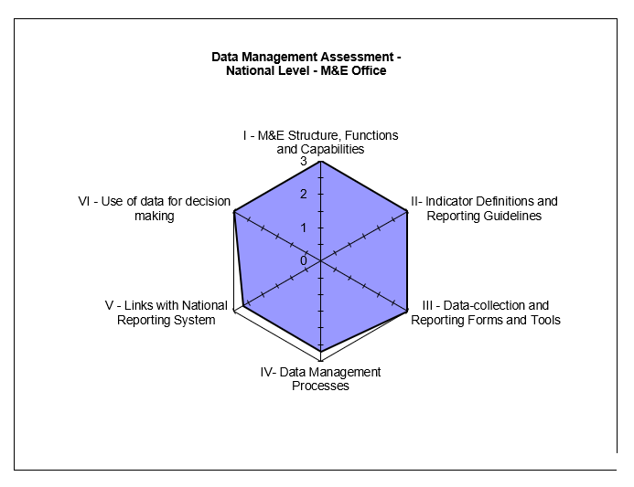

#### STRENGTHS – LOPIN 1 CENTRAL M&E UNIT

* Availability of an M&E Manual for LOPIN Region 1.
* Clear responsibilities for the review of data at the central level assigned to the Senior M&E Officer and M&E Director.
* Use of NOMIS for data reporting.
* Availability of trained M&E staff.
* Engagement of ad-hoc staff as monitors to help with quality checks on data.
* Introduction of mobile phones to track ad-hoc monitors to ensure they are operating according to their job description.
* Training activities included in LOPIN 1 work-plan.
* Participation in quarterly data review meetings at state levels where M&E results are presented and discussed.
* Development of a published article on school absenteeism among OVC in Lagos state in 2017.
* Good data demand and use.

#### areas for improvement – LOPIN 1 CENTRAL M&E UNIT

* LOPIN 1 Data Management SOP does not include section on CMP.
* Data generated by the current version of the NOMIS at the central IP office did not tally with data reported for FY 2018 SAPR.

#### RECOMMENDATIONS – LOPIN 1 CENTRAL M&E UNIT

* Development and use of CMP to guide and document data changes/update.
* Update NOMIS software to the most recent version to address NOMIS data discrepancies.

### 4.1.2 LOPIN 1 STATE-LEVEL M&E UNIT

#### 4.1.2.1 M&E STRUCTURE, FUNCTIONS, AND CAPABILITIES

The LOPIN 1 state level M&E unit is operated by the M&E Officer who performs the following functions:

* Conducts supervisory visits;
* Aggregates state-level data;
* Conducts DQAs;
* Conducts monthly data quality checks on reported data; and
* Provides feedback to CBOs on reported data.

All state-level M&E Officers reported to have received relevant training to carry out their assigned responsibilities. Ebonyi state reported that the most recent training was conducted in December 2017. M&E training certificates were sighted in Lagos State. A suitable state office staff with M&E training fills in the gap for the M&E Officer when not available. Feedback is received at the state level from the central on data reported. The state officers conduct visits to the CBOs at least once in a month while the central M&E unit visits the states quarterly. There were no major differences in the M&E structure, functions, and capabilities of the three states assessed.

#### 4.1.2.2 INDICATOR DEFINITION AND REPORTING GUIDELINES

The three LOPIN 1 state offices use the PEPFAR Nigeria FY18 OVC PIRS that defines the indicators and the methods for calculating them. In addition, M&E activities are guided by the M&E Manual for LOPIN Region 1 which includes details on reporting requirements and deadlines.

#### 4.1.2.3 DATA COLLECTION AND REPORTING FORMS AND TOOLS

The states aggregate data from the NOMIS export files received from CBOs. The states also ensure the availability and consistent use of the national OVC tools by the CBOs. As at the time of the DQA exercise, there was no stock out of reporting tools at the three state offices. Instructions were provided to the states on utilization of the tools through the guidance available in the M&E manual.

#### 4.1.2.4 DATA MANAGEMENT PROCESSES

At the three states offices, data verification checks are conducted on CBO data before submissions are made to the central M&E unit during monthly coordination meetings, DQA exercise and quarterly data review meetings. Inconsistencies uncovered in reported data are communicated to CBOs through e-mails and telephone calls. At Akwa Ibom state, documented evidence of action plans taken to resolve data issues were not sighted. The state offices send emails to follow-up with the CBOs on incomplete and inaccurate reports, however, there are no written guidelines on the processes and procedures to address late incomplete or inaccurate reports from the CBOs.

All three states back up their data monthly using cloud technology, hard drive and e-mail. The states are aware of the storage period required for source documents (ten years) as stipulated in the LOPIN 1 M&E Manual. The manual also contains guidelines on data storage and archiving.

#### 4.1.2.5 LINKS WITH THE NATIONAL REPORTING SYSTEM

Data on the two indicators generated at the two state offices have links with the national reporting system through data reported to both state Ministries of Women’s Affairs and Social Development (MWASD). Data are also reported by both state offices to the LOPIN 1 central office.

#### 4.1.2.6 USE OF DATA FOR DECISION MAKING

The capacity of state M&E staff have been built to produce charts from analyzed data and to disseminate the same to various key stakeholders for decision making during monthly coordination meetings and quarterly joint data review meetings. At the state offices, data have been used to develop strategies to achieve set targets and to address identified issues.

Figure 3, Figure 4 and Figure 5 below show the spider graph of the M&E systems assessment for Akwa Ibom, Lagos and Rivers states respectively. It can be observed that the data management system at Akwa Ibom state office needs to be improved on while the data collection and reporting system at Akwa Ibom and Rivers states also need to be strengthened. All three states have gaps regarding links with the national reporting system which occurred because of the parallel data reporting channels i.e., to government and donor agencies. However, there are mechanisms in place to harmonize reported data to both reporting entities such as data harmonization meetings at the state level.

Figure 3. Spider Graph of M&E Systems Assessment: LOPIN 1 State-Level, Akwa Ibom State

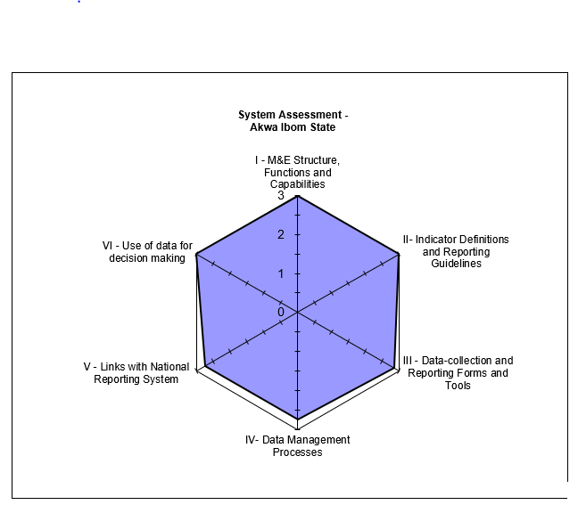

Figure 4. Spider Graph of M&E Systems Assessment: LOPIN 1 State-Level, Lagos State

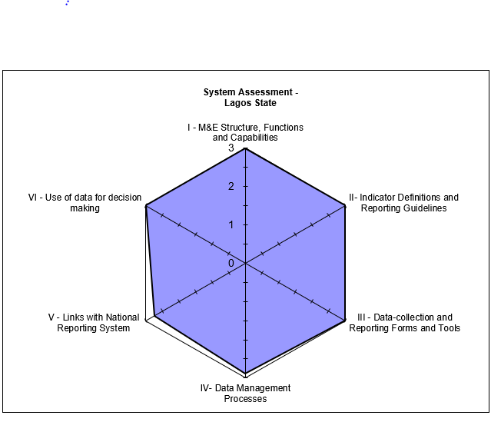

*Figure 5. Spider Graph of M&E Systems Assessment: LOPIN 1 State-Level, Rivers State*

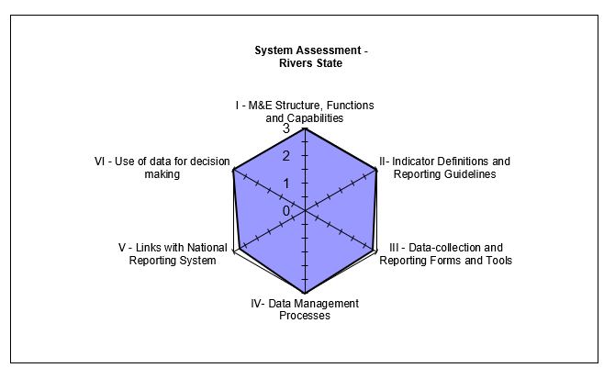

#### 4.1.2.7 LOPIN 1 STATE LEVEL – STRENGTHS

* Data verification checks at Akwa Ibom and Rivers states were accurate for the two indicators. Data verification was only accurate for the OVC_SERV indicator in Lagos state.
* All state level M&E Officers have received relevant training to carry out their assigned responsibilities.
* The state level M&E coordinators provide technical support to the supported CBOs.
* SOP for data management available and in use.
* PIRSs for both indicators sighted and in use.
* NOMIS database is used for data reporting.
* Multiple backup processes are in use e.g., hard drive and cloud.
* Data are collated and presented in charts, tables etc. and disseminated to different stakeholders for decision making.

#### 4.1.2.8 LOPIN 1 STATE LEVEL – AREAS FOR IMPROVEMENT

* Activity data are not consistently backed up monthly in Akwa Ibom state.
* Late reporting by CBOs in Akwa Ibom state.
* No written procedure(s) to address incomplete, late, inaccurate and feedback to lower reporting levels in Akwa Ibom and Lagos states.
* No CMP to guide reporting of data updates.
* Data loss on the NOMIS following data export in Lagos state.

#### 4.1.2.9 RECOMMENDATIONS

* Develop CMP to guide reporting of data updates.
* Develop guidelines to address incomplete, late, inaccurate and feedback of reported data to lower reporting levels.
* Update the NOMIS with the latest version of the software to prevent data loss following data export.
* Ensure compliance to data back-up guidelines in Akwa Ibom state
* Ensure compliance of CBOs in Akwa Ibom state to reporting timelines.

### 4.1.3 LOPIN 1 SERVICE DELIVERY LEVEL (CBOs)

A comparative M&E systems assessment of the eight CBOs visited by the DQA teams is presented below in narrative and tabular form, with details of the specific functional areas.

#### 4.1.3.1 M&E STRUCTURE, FUNCTIONS, AND CAPABILITIES

All relevant staff at the CBOs within the three states have received relevant M&E training. Some areas covered during the trainings include a refresher training on the NOMIS (December 2017) and training on OVC technical activity areas (February 2018). The LOPIN 1 training manual was sighted at two CBOs and training certificates were sighted at six CBOs.

Data are reviewed by the CBO M&E Officer and sometimes alongside with other staff of the CBO before they are reported to the next level. A staff within the CBO trained in M&E acts as a suitable back stop when the M&E Officer is unavailable. The state offices provide feedback to the CBOs on reported data during monthly data review/data validation meetings and via e-mails (six CBOs). The CBOs also receive monthly supervision visits from the IP state offices.

#### 4.1.3.2 INDICATOR DEFINITION AND REPORTING GUIDELINES

The FY18 PIRS provided by the central M&E unit was available at all the CBOs visited. The central M&E unit also issued guidelines to its CBOs on reporting requirements and deadlines for submission of reports which are contained in the M&E manual.

#### 4.1.3.3 DATA COLLECTION AND REPORTING FORMS AND TOOLS

At all the CBOs, the data collection tools and forms which include household vulnerability assessment form, enrollment form, VC service form, risk assessment form, referral form, request and result form and HIV test result form, were available. Clear instructions on usage are contained in the guidelines for national OVC activity data collection and reporting tools. National paper-based tools and the NOMIS database were consistently utilized during the period under review. All CBOs had adequate supply of data collection tools except at AOCF where there was stock out of VC service forms. Outdated service forms were being used at HCF.

#### 4.1.3.4 DATA MANAGEMENT PROCESSES

Diverse methods are employed to ensure data quality and prevent double counting at the CBOs. In this regard, the findings at the CBOs visited include:

1. Utilization of a built-in NOMIS function that identifies and removes duplicate values (sighted at 100 percent of CBOs visited);
2. M&E staff review data and conduct spots checks;
3. Export of data from the NOMIS to an Excel spreadsheet, used in sorting data and conducting cross checks (LCIF CBO); and
4. Conduct of internal DQAs (BROKLINE and HCP CBOs).

The DQA team however discovered a beneficiary who was registered twice in the NOMIS with all details the same except for the unique ID number (AOCF CBO).

CBOs back up data periodically using both cloud technology and an external hard drive. Complete details of backup methods for CBOs in Akwa Ibom, Lagos and Rivers states are provided in the Annex (Table 16,Table 17 and Table 18).

In terms of beneficiary data confidentiality, all CBOs store folders in locked cabinets, in rooms under lock and key. Staff at the CBO are made to sign confidentiality forms, restricting them from unauthorized sharing of beneficiary information. Non-CBO staff are also made to sign confidentiality forms before gaining access to any beneficiary information. The NOMIS database at the CBOs is password protected, with limited access to only authorized staff. A good filing system was observed at all the CBOs except at HCF where the service forms were not orderly arranged within the beneficiary folders.

All the CBOs were aware of the storage period required for source documents, referencing the LOPIN 1 M&E Manual and the LOPIN 1 sub agreement document with the CBOs.

#### 4.1.3.5 LINKS WITH NATIONAL REPORTING SYSTEM

Indicator data generated at the CBOs have links with the national reporting system through data reported to respective LGA OVC focal persons, who in turn report to the State MWASD. Data are also reported by the CBOs within states to their respective LOPIN 1 state offices.

The NOMIS system clearly records information about where the services are rendered, using standardized naming conventions (e.g., the state, LGA, ward) and the unique identification codes.

#### 4.1.3.6 USE OF DATA FOR DECISION MAKING

All the CBOs reported that the M&E Officer and M&E Assistants develop charts, tables, etc. for dissemination to various stakeholders. ARFH provides guidance to the CBOs on data use during data review meetings, monthly coordination meetings, supervisory visits and data validation meetings.

#### 4.1.3.7 STRENGTHS

* CBOs have trained M&E staff.
* Suitable backstop to fill in for the M&E Officer when not available.
* Several mechanisms are in place to ensure confidentiality of beneficiary records and to minimize data quality issues.
* PIRS on the indicators, M&E Manual for LOPIN Region 1 and national OVC tools are available and in use.
* NOMIS software is in use and password protected
* Beneficiaries’ folders are stored under lock and key with limited access.
* Data are backed up routinely using an external drive and the cloud.
* Data are analyzed and used to inform activity implementation.
* The written policy on the storage period of source documents was available at all CBOs.

#### 4.1.3.8 AREAS FOR IMPROVEMENT

* Data entry errors were observed in the NOMIS (duplicate entry at AOCF CBO).
* Service forms not accurately and completely filled by Community Volunteers (CVs) at BF, HCF and AOCF CBOs.
* Old computers with inadequate capacity for large data are in use, making data entry slow (BF CBO).
* Stock out of service forms (AOCF CBO) and use of outdated service forms (HCF CBO).
* Disorderly arrangement of service forms in the household folders (HCF CBO).
* Data Officer not appending his signature whenever corrections are made on service forms (HCF CBO).
* CMP not available to guide reporting of data updates.

#### 4.1.3.9 RECOMMENDATIONS

* Conduct refresher training for CVs on completion of data tools (BF, AOCF and HCF CBOs).
* Provide updated service forms to AOCF and HCF and discourage use of outdated service forms.
* Upgrade computer software to a higher capacity or procure a computer with capacity for large data, to improve the process of data entry into the NOMIS (BF CBO).
* Conduct capacity building for CBOs on proper filing of source documents (HCF CBO).

## 4.2 DATA QUALITY STANDARDS

### 4.2.1 VALIDITY

Validity is the extent to which a measurement is well-founded and corresponds accurately to the real world. It pertains to measuring what is intended to be measured. Details of the review of data quality in the context of the OVC indicators are provided below.

#### 4.2.1.1 DATA COLLECTION

*Indicator 1- OVC_SERV:* The data are collected during provision of services and follow up visits by CVs to OVC and caregivers using the “Vulnerable Children Service Form,” “Caregiver/Household Head Service Form,” and the graduation forms/checklist/plans.

*Indicator 2-OVC_HIVSTAT:* The data, including HIV status are collected at the point of registration into the OVC activity, during provision of service and follow up visits using the “Vulnerable Children Enrollment Form,” “Vulnerable Children Service Form,” and “Vulnerable Children Follow-up Child Status Index (CSI) Form.” In addition, other tools such as HIV test results, HIV risk assessment results and other confidential and case management and monitoring tools are used to document the HIV status of beneficiaries.

#### 4.2.1.2 DOES THE DATA COLLECTED MEASURE WHAT IT IS SUPPOSED TO MEASURE?

*Indicator 1: OVC_SERV:*

As part of the OVC indicator, the following data are collected:

* Total number of VC who are served (age 0-17) i.e., OVC that actually received services in the past three months;
* Total number of OVC caregivers (age 18 and above); and
* Total number of OVC that graduated.

The indicator matches the PIRS and is a direct measurement as per the definition. This corresponds to what is needed or intended for an OVC IM.

*Indicator 2: OVC_HIVSTAT:*

As part of the OVC indicator, the following data are collected:

* Total number of OVC less than 18 years with HIV status reported to IPs (including report of no status).

The OVC_HIVSTAT indicator matches the PIRS and is a direct measurement according to the definition. The data collected by the IM measures the total number of OVC less than 18 years who reported their HIV status including report of no status to LOPIN 1. Data for this indicator is also collected as disaggregates to make up the whole: ‘Reported HIV positive to IP,’ ‘Reported HIV negative to IP,’ and ‘No HIV status reported to the IP.’

#### 4.2.1.3. UNDERSTANDING THE INDICATOR DEFINITION

The PIRSs for the two indicators were available at all the levels assessed. Staff were conversant with the PIRS document at the state and CBO levels.

#### 4.2.1.4 DATA REPORTING

Indicator 1: OVC_SERV

As shown in Figure 6 below, 100 percent of the OVC_SERV data reported by the three states to the central level were available, and matched the data reported to USAID for the FY 2018 SAPR period. Data reported by CBOs to the states were verified and also found to be 100 percent accurate for the three states. With consideration of the +/- ten percent acceptable variance for determining the accuracy of verified data, 100 percent of reported CBO data verified were within the acceptable range. Overall average accuracy of verified data across all sites (central, state and CBOs) was 100 percent, hence, reported data are considered suitable for decision making.

Figure 6. Indictor 1: OVC_SERV Data Verification by level of reporting system

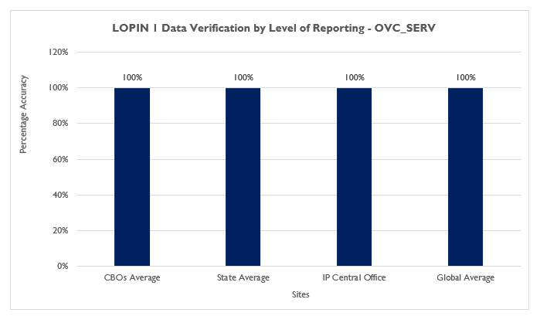

Indicator 2: OVC_HIVSTAT

As shown in Figure 7, 100 percent of the OVC_HIVSTAT data reported by the three states to the central level were available, and matched the data reported to USAID for the FY 2018 SAPR period. The data for each disaggregate of the indicator: ‘Reported HIV positive to the IP,’ ‘Reported HIV negative to the IP,’ and ‘No HIV status reported to the IP’ were similarly 100 percent accurate at the central level.

At the state level, indicator data reported by Akwa Ibom and Rivers state offices for both the total OVC_HIVSTAT numerator and the disaggregates were100 percent accurate. Data reported by the Lagos state office for the numerator total had a verification factor of 99 percent accounted for by difference in the reported and verified ‘No HIV status reported to the IP’ disaggregate data whose verification factor was 87 percent (Figure 8).

Out of the eight CBOs visited in the three states, five CBOs had verified data which matched that reported to the state level for all three disaggregates and the total OVC_HIVSTAT numerator total, hence 100 percent accurate. BF CBO (Akwa Ibom state), Chamagne Foundation (Lagos state) and AOCF (Lagos state) had 96, 99 and 99 percent verification factors respectively (Figure 9). The verification factors for these three CBOs were not 100 percent due to incorrect ‘Reported HIV negative to the IP’ disaggregate data at Chamagne Foundation and AOCF and ‘No HIV status reported to the IP’ disaggregate data at BF and AOCF.

With consideration of the +/- ten percent acceptable variance for determining the accuracy of verified data, 100 percent of reported total OVC_HIVSTAT data verified were within the acceptable range. Overall average accuracy of the verified total OVC_HIVSTAT data across all sites (central, states and CBOs) was 100 percent, hence reported data are considered suitable for decision making. The same applies for the indicator disaggregates, with the exception of the ‘No HIV status reported to the IP’ disaggregate data reported by BF (86 percent verification factor) and the Lagos state IP office (87 percent verification factor), which the total OVC_HIVSTAT verification factor average masks.

Figure 7: OVC_HIVSTAT Data Verification Factors by level of reporting system for LOPIN 1

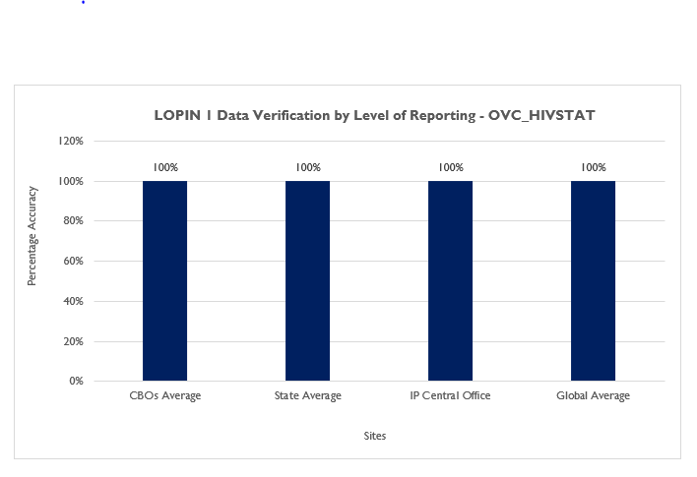

Figure 8: OVC_HIVSTAT Data Verification Factors for Numerator Disaggregate at the LOPIN 1 States

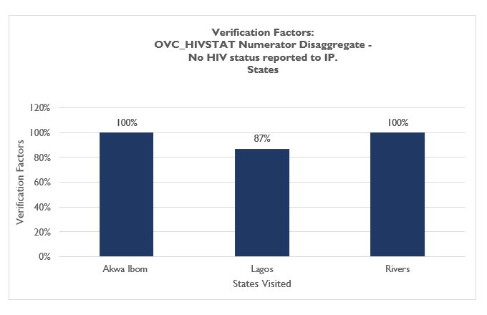

Figure 9: OVC_HIVSTAT Data Verification Factors for Numerator Total at the LOPIN 1 CBOs

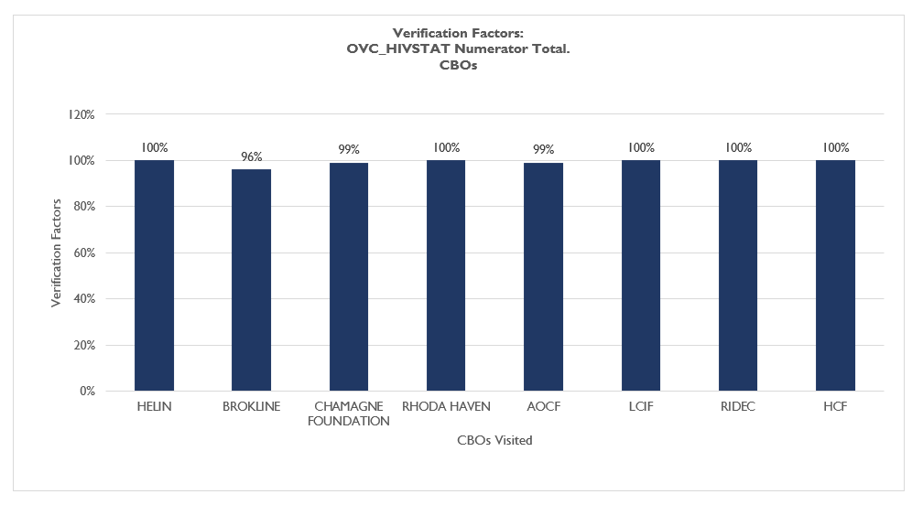

#### 4.2.1. STRENGTHS

* Data for both indicators are collected as stipulated by the indicator reference guide using national approved tools.
* The “HIV status update form” on the NOMIS is used to input and update the HIV status of the beneficiaries for accurate reporting.

#### 4.2.1.6 VALIDITY ISSUES IDENTIFIED

Validity Issue 1:Transcription/data entry errors from incomplete entries into the source documents and into NOMIS.

Indicator 1: OVC_SERV (Table 5)

Errors from documenting incorrect entries in the service forms were observed at all the eight CBOs. Seven percent of beneficiary forms reviewed during the cross checks had incomplete, missing or incorrect entries. Some of the errors observed included dated forms which did not specify the year, incomplete demographic information and missing service forms in the folders. During the cross-checks from the NOMIS to the source documents, data entry errors were identified at seven of the eight (87.5 percent) CBOs visited. Thirty-three percent of NOMIS entries reviewed showed errors, one of which was a beneficiary enrolled twice on the NOMIS. Data loss on the NOMIS following data export was one of the reasons stated for the data inconsistencies.

Table 5. Cross-Check Findings from LOPIN 1 CBOs in Lagos, Rivers and Akwa Ibom River States OVC_SERV

|  |  |  |  |  |  |  |  |  |  |  |
| --- | --- | --- | --- | --- | --- | --- | --- | --- | --- | --- |
| Cross Check Findings_ LOPIN 1 (OVC_SERV) | | | | | | | | | | |
| Cross Check Findings | **Lagos** | | | **Rivers** | | | **Akwa Ibom** | | **Total** | |
| **CF** | **RHN** | **AOCF** | **LCIF** | **RIDEC** | **HCF** | **HELIN** | **BF** | **No.** | **%** |
| Total cross checks: NOMIS to beneficiary folders and vice versa | 20 | 20 | 22 | 20 | 20 | 20 | 20 | 20 | 162 |  |
| Total cross checks by beneficiary forms | 120 | 115 | 100 | 100 | 100 | 100 | 100 | 100 | 835 |  |
| Number of beneficiary forms with incomplete, missing or incorrect entries | 5 | 11 | 9 | 5 | 3 | 3 | 15 | 9 | 60 | 7% |
| Number of NOMIS entries that are incomplete, missing or incorrect | 7 | 12 | 6 | 0 | 3 | 1 | 12 | 12 | 53 | 33% |

Indicator 2: OVC_HIVSTAT (Table 6)

Errors from documenting incorrect entries in the service forms were observed at seven CBOs. Three percent of beneficiary forms reviewed during the cross checks had incomplete, missing or incorrect entries. In addition to the errors already mentioned in the section on OVC_SERV above, it was observed that the HIV status of some beneficiaries sighted in the NOMIS were not present on the corresponding service forms. During the cross-checks from the NOMIS to the source documents, data entry errors were identified at three of the eight (37.5 percent) CBOs visited. Five percent of NOMIS entries reviewed showed errors already mentioned in the section on OVC_SERV above.

Table 6. Cross-Check Findings from LOPIN 1 CBOs in Lagos, Rivers and Akwa Ibom River States OVC_HIVSTAT

|  |  |  |  |  |  |  |  |  |  |  |
| --- | --- | --- | --- | --- | --- | --- | --- | --- | --- | --- |
| Cross Check Findings_ LOPIN 1 (OVC _HIVSTAT) | | | | | | | | | | |
| Cross Check Findings | **Lagos** | | | **Rivers** | | | **Akwa Ibom** | | **Total** | |
| **CF** | **RHN** | **AOCF** | **LCIF** | **RIDEC** | **HCF** | **HELIN** | **BF** | **No.** | **%** |
| Total cross checks: NOMIS to beneficiary folders and vice versa | 20 | 20 | 20 | 20 | 20 | 20 | 20 | 20 | 160 |  |
| Total cross checks by beneficiary forms | 120 | 100 | 100 | 100 | 100 | 100 | 100 | 100 | 820 |  |
| Number of beneficiary forms with incomplete, missing or incorrect entries | 0 | 2 | 5 | 10 | 2 | 2 | 3 | 1 | 25 | 3% |
| Number of NOMIS entries that are incomplete, missing or incorrect | 2 | 0 | 4 | 0 | 0 | 0 | 2 | 0 | 8 | 5% |

Validity Issue 2**:** Errors in data verification

Findings from recounted data aggregated at the CBOs for the two indicators showed inaccurate data at three CBOs. OVC_SERV data was under-reported by AOCF and over-reported by BF CBO, while OVC_HIVSTAT data was over-reported by BF, CF and AOCF CBOs. The reason stated for the data verification errors is data loss from the NOMIS following data export. The verification results for the two indicators are shown graphically in Figure 10. The numeric values for verification factors at state and CBO levels are shown in the Annex section (Table 12,Table 13, Table 14 and Table 15).

Figure 10. Verification Factors for LOPIN 1 Akwa Ibom, Lagos and Rivers States and CBOs

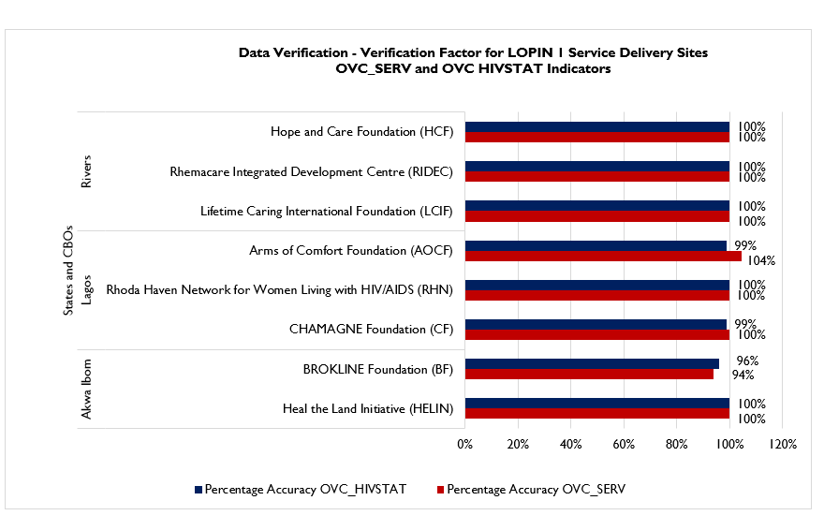

#### 4.2.1.7 RECOMMENDATIONS FOR IMPROVING DATA VALIDITY

* Improve supervisory efforts with the CBOs to ensure completeness and accuracy of data entry and proper use of the NOMIS.
* Provide refresher training on the NOMIS software to DECs.
* Provide support to CBO M&E Officers to conduct periodic folder audits to resolve discrepancies observed during cross checks.
* Update the NOMIS software to the most recent version to address NOMIS data discrepancies.

### 4.2.2 RELIABILITY

#### 4.2.2.1 MECHANISMS TO ENSURE DATA RELIABILITY

The LOPIN 1 IM utilized the national OVC reporting tools consistently during the period under assessment. Data reported by LOPIN 1 for the two indicators are retrieved from the NOMIS and reported only as the: (1) number of beneficiaries served by PEPFAR OVC activities for children and families affected by HIV; and (2) OVC less than 18 years with HIV status reported to the IP. All LOPIN 1 CBO and state-level reports for the period under assessment were available for review and complete along the same reporting format.

At the state level, the NOMIS aggregation and reporting platform was consistently used. Data exported from the NOMIS were aggregated and exported quarterly to the LOPIN 1 central office, were it was extracted and reported to USAID using the Data for Accountability Transparency Impact Monitoring (DATIM) reporting platform. This ensured consistency and reliability in data collection processes across all reporting levels.

One of the CBOs (AOCF) experienced stock out of VC service form while another CBO (HCF) used outdated OVC service forms.

#### STRENGTHS

* Use of national reporting OVC tools.

#### AREAS FOR IMPROVEMENT

* Stock out of VC service forms at AOCF CBO.
* Use of outdated service forms at HCF CBO.

#### RECOMMENDATION

* Ensure adequate supply of updated reporting tools to all CBOs, especially AOCF CBO.
* Ensure CBO compliance to usage of only updated reporting tools.

### 4.2.3 PRECISION

#### 4.2.3.1 MECHANISMS TO ENSURE DATA PRECISION

The data collected in the enrollment, service and follow-up forms are entered in the NOMIS in a consistent manner, including providing a detailed level of information on beneficiaries served and the status of OVC less than 18 years. The nationally approved data fields in the forms are entered into the NOMIS. Since the NOMIS has household-level and individual-level data, it has sufficient details and precision to provide information on beneficiaries served and HIV status of OVC less than 18 years, while ensuring that beneficiary confidentiality is protected. Data elements on the forms have information fields such as date, sex, age, child HIV status, and services provided, which also have corresponding fields in the NOMIS. In addition, the NOMIS has data entry page that enables update of the HIV status of beneficiaries. The level of precision in the data collection forms and the NOMIS matches the requirements in the PIRS.

### 4.2.4 TIMELINESS

#### 4.2.4.1 MECHANISMS TO ENSURE TIMELINESS

Staff at the LOPIN 1 Central M&E unit claimed to have reported data to USAID in a timely manner, and received reports from the state offices in a timely manner through the NOMIS. Emails showing receipt of data reported by the states were sighted at the central office. Data reported by the CBOs to the state offices were timely for Lagos and Rivers states (100 percent reporting performance) and not timely for Akwa Ibom (67 percent reporting performance). CBO reports are expected on the fifth day of a new month however, some CBOs reported data on the 17th day of a new month. No documented policy was sighted at the Akwa Ibom state office that addresses late and incomplete reporting by CBOs. Figure 11 shows the reporting performance results for LOPIN 1 states.

Figure 11. Reporting Performance – Results for LOPIN 1 States

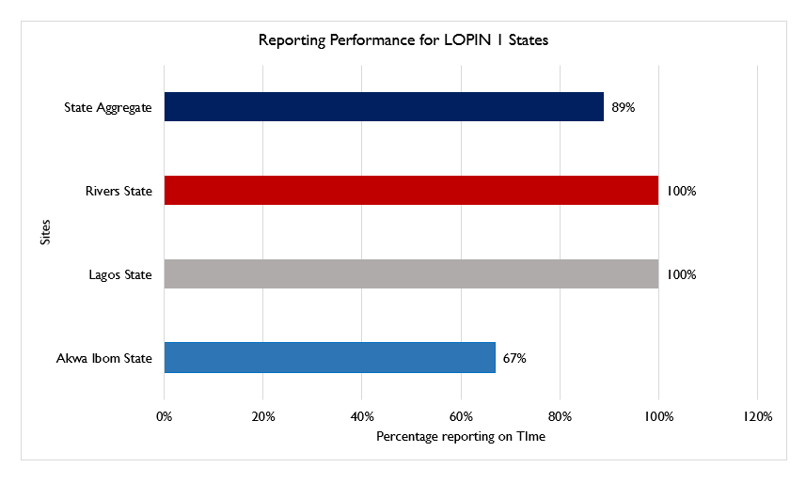

#### AREAS FOR IMPROVEMENT

* No policy to guide late and incomplete reporting by lower reporting levels.
* Untimely submission of reports by CBOs in Akwa Ibom state.

#### RECOMMENDATION

* Develop written procedures to address late and incomplete reporting by lower reporting levels.
* Ensure CBOs’ compliance to reporting timelines.

### 4.2.5 INTEGRITY

#### 4.2.5.1 MECHANISMS TO ENSURE DATA INTEGRITY

LOPIN 1 data collection and management process at the Central IP level is through the NOMIS. Data validation processes executed by its M&E team ensures that the data collated by LOPIN 1 undergoes data quality checks.

At the state level, LOPIN 1 M&E Officers conduct data quality checks on data in the NOMIS platform. The password-protected NOMIS at the state level ensures confidentiality. Table 7 and Table 8 presents the mechanisms used by LOPIN 1 to ensure integrity in activity implementation and data reporting:

Table 7. Mechanisms for Ensuring Data Integrity Across LOPIN 1 Sites

|  |  |  |
| --- | --- | --- |
| CENTRAL | STATE LEVEL | CBO LEVEL |
| * Built-in checks in NOMIS that remove double entries * Supervisory visits * Data Quality Audits * Quarterly review meetings | * Dedicated staff conducting quality checks * Built-in checks in NOMIS that remove double entries * Monthly coordination meetings * Data review meetings * Supervisory visits to CBOs * Follow-up emails and phone calls to CBOs | * The use of the password-protected NOMIS (100 percent) * Built-in checks in NOMIS that remove double entries (100 percent) * Dedicated staff to check for data quality (100 percent) * Limited access to the filing cabinet where source documents are kept (100 percent) * Cross-check of NOMIS entries by exporting to Excel and using sort and filter application to check for errors in data before exporting to next level (One CBO) * Conduct of internal DQA to ensure accuracy (25 percent) |

Table 8. Mechanisms for Ensuring Data Integrity Across LOPIN 1 State Offices

|  |  |  |  |
| --- | --- | --- | --- |
| Data Management Process | Akwa Ibom | Lagos | Rivers |
| Quality control to avoid double counting | * Relies on built-in cross-checks in NOMIS | * Relies on built-in cross-checks in NOMIS | * Relies on built-in cross-checks in NOMIS * M&E Officers verify the data before submission to the next level |
| Confidentiality | * Password on NOMIS with limited access | * Password on NOMIS with limited access | * Password on NOMIS with limited access |
| Backup procedure | * Hard Drive * E-mails | * External Drive, Cloud | * External Drive, Cloud |
| Feedback mechanism | * Data Review Meeting * E-mails | * Data verification exercise * E-mails * Monthly coordination meetings | * Phone calls * E-Mails |

#### STRENGTHS

All the mechanisms outlined above are strengths in the M&E system of LOPIN 1, to ensure the integrity of indicator data.

#### AREAS FOR IMPROVEMENT

* Several corrections on OVC service dates were observed on the service forms at CBOs in Akwa Ibom state.
* Data quality cross check of NOMIS data with an Excel hard copy of the exported data was observed at only one CBO.

#### RECOMMENDATION

* Provide refresher training for CBO staff on maintaining the integrity of data when filling data collection tools.
* Ensure all CBOs conduct data quality cross checks of NOMIS electronic data with an Excel hard copy containing exported data before reporting to the next level.

# Action plan for LOPIN 1

The suggested action plan for the various levels are outlined below (Central Level Action Plan –Table 9; State Level Action Plan – Table 10; and CBO Level Action Plan – Table 11).

## 5.1 ACTION PLAN FOR LOPIN 1 central LEVEL

Table 9. Action Plan for LOPIN 1 Central Level

|  |  |  |  |
| --- | --- | --- | --- |
| Areas for Improvement | Description of Action Point | Responsible | Timeline |
| Data generated by the current version of NOMIS at the HQ office did not tally with data reported for FY 2018 SAPR. | * Update NOMIS software to the most recent version to address NOMIS data discrepancies. | LOPIN 1 M&E Director | September 2018 |
| LOPIN 1 Data Management SOP does not include section on CMP. | * Update the LOPIN 1 Data Management SOP to include section on CMP to guide reporting of data updates. * Disseminate updated SOP to lower reporting levels and ensure usage compliance. | LOPIN 1 M&E Director | September 2018 |
| LOPIN 1 Data Management SOP does not include a section that addresses incomplete, late, inaccurate reporting and feedback to lower reporting levels. | * Update the LOPIN 1 Data Management SOP to include section that addresses incomplete, late, inaccurate reporting and feedback to lower reporting levels. * Disseminate updated SOP to lower reporting levels and ensure usage compliance. | LOPIN 1 M&E Director | September 2018 |

## 5.2 ACTION PLAN FOR LOPIN 1 STATE LEVEL

Table 10. Action Plan for LOPIN 1 State Level

|  |  |  |  |
| --- | --- | --- | --- |
| Areas for Improvement | Description of Action Point | Responsible | Timeline |
| Errors observed in reported data during data verification. | * Improve supervisory efforts with the CBOs to ensure accurate data entry and proper use of the NOMIS. * Conduct refresher training for DECs on the NOMIS software. * Ensure all CBOs conduct data quality cross checks between NOMIS soft copy data and a hard copy Excel NOMIS data before reporting. * Provide support to CBO M&E Officers to conduct periodic folder audits to resolve discrepancies observed during cross checks. | LOPIN 1 M&E State Officers | September 2018 |
| Data loss on NOMIS following data export. | * Update NOMIS with the latest version of the software to prevent data loss following data export. | LOPIN 1 M&E State Officers | September 2018 |
| Untimely submission of reports by CBOs in Akwa Ibom state. | * Ensure compliance of CBOs in Akwa Ibom state to reporting timelines. | LOPIN 1 M&E Officer (Akwa Ibom) | September 2018 |
| Activity data not consistently backed up monthly in Akwa Ibom state. | * Ensure compliance to data back-up guidelines in Akwa Ibom state. | LOPIN 1 M&E Officer (Akwa Ibom) | September 2018 |
| Service forms not accurately and completely filled by CVs at BF, HCF and AOCF CBOs.  CBO Data Officer not appending his signature whenever corrections are made on service forms (HCF). | * Conduct refresher training for CVs on completion of data tools (BF, AOCF and HCF). | LOPIN 1 M&E State Officers | September 2018 |
| Stock out of service forms (AOCF) and use of outdated service forms (HCF). | * Ensure adequate supply of updated reporting tools to all CBOs, especially AOCF. * Ensure CBO compliance to usage of only updated reporting tools. | LOPIN 1 M&E State Officers | September 2018 |
| Disorderly arrangement of service forms in the household folders (HCF). | * Conduct capacity building for CBOs on proper filing of source documents (HCF). | LOPIN 1 M&E State Officers | September 2018 |

## 5.3 ACTION PLAN FOR LOPIN 1CBO LEVEL

Table 11. Action Plan for LOPIN 1 CBO-Level

|  |  |  |  |
| --- | --- | --- | --- |
| Areas for Improvement | Description of Action Point | Responsible | Timeline |
| Old computers with inadequate capacity for large data are in use, making data entry slow (BF). | * Upgrade computer software to a higher capacity or procure a computer with capacity for large data, to improve the process of data entry into the NOMIS (BF). | BF CBO Program Manager | September 2018 |
| Data transcription and entry errors. | * Improve supervisory efforts with the CVs and DECs to ensure completeness and accurate data entry into the service forms and into the NOMIS. * Conduct regular folder audits to resolve discrepancies observed during cross checks. | All CBO M&E Officers | September 2018 |

# Limitations and Constraints

1. DQAs at a country level are complex exercises and require significant resources and effort on the part of the commissioning agency, the agency conducting the DQA, IPs, and government functionaries in the relevant sectors. As mentioned in USAID’s “How-To Note: Conduct a DQA,”[5] notification of an impending DQA can also cause stress for the IP, given the ramifications of program performance and the potential uncertainty of USAID’s expectations. Although the MEL Activity DQA team tried to allay initial apprehensions of the IP and its staff about the outcomes from the DQA, there may have been residual concerns that could not be fully addressed. The DQA team emphasized to the IP that subsequent to completion and dissemination of the final report, the DQA results are intended to be a tool for USAID and the IP to work together, to resolve any data quality issues or limitations discovered during the exercise.

2. The sampling of the three LOPIN 1 states (Akwa Ibom, Lagos and Rivers), as well as the CBO sites visited in the states was based on a purposive methodology, with consideration to security and feasibility issues, and was also guided by USAID. The ideal sampling methodology would have been to use a statistically valid scientific method, as described in the MEASURE Evaluation DQA guidelines[6]. Implementation of a statistically valid method was constrained by security and other eligibility considerations outlined in section 0. This was partially compensated for by the number of CBOs covered during the DQA.

3. To ensure adequate time for the DQA teams in the field to complete all aspects of the DQA, including the M&E systems assessment, review of the data quality standards, data verifications, and cross-checks, a limited number of cross-checks were performed at each CBO (service delivery level). At most CBOs, at least twenty beneficiary folders were reviewed during the cross-checks. As described in detail in section 3.1, this limitation was partially addressed by using random selection of beneficiary folders (where feasible) from all household folders for the two reported quarters. Also, cross-checks were attempted in two directions—i.e., ten records were traced from the beneficiary forms/household folders to the NOMIS, and an additional ten unique beneficiary records were traced from the NOMIS back to the beneficiary folders for cross-verification.

# Conclusions

From the USAID/Nigeria and PEPFAR perspective, the DQA for OVC indicators serves to meet the operational policy requirements of USAID/Washington and USAID/Nigeria. It also serves to review the M&E system, identify best practices, and develop recommendations to improve existing systems, for better reporting of activity indicators in subsequent funding cycles.

The M&E system areas of strength across the three LOPIN 1 levels assessed include the availability of trained M&E staff with clearly assigned responsibilities, availability of a data management SOP that guides M&E processes and the availability and use of the PEPFAR indicator reference guide. Another area of strength was in the use of analyzed data to inform activity implementation. The areas for improvement across the levels assessed include the need to update the M&E manual for LOPIN region 1 with CMP guidelines to inform reporting of data updates. The manual also needs to be updated with guidelines that address incomplete, late and inaccurate data reporting from lower reporting levels.

With reference to the ADS 201 definition of data quality standards (Table 1), the OVC_SERV and OVC_HIVSTAT indicator data reported by LOPIN 1 can be judged valid. Data verification across the three levels assessed were within the +/- ten percent acceptable variance for determining the accuracy of verified data for the OVC_SERV indicator data. The same applies for the OVC_HIVSTAT indicator data with the exception of over-reported numerator disaggregate data by a CBO in Akwa Ibom state and the IP Lagos state office, which the total OVC_HIVSTAT verification factor average masks. Data was also found to be reliable, precise and have integrity. Timeliness of reported data can be improved by providing technical assistance to CBOs prior to reporting deadlines to identify and resolve issues resulting in late submission of reports.

USAID/Nigeria is recommended to establish a community of practice of NOMIS users to facilitate the identification of effective approaches to resolving the NOMIS software issues and data loss in NOMIS following data export and NOMIS software upgrade.

# Annexes

## 8.1 LIST OF SITES VISITED AND LOCATIONS

A complete list of sites and locations visited is provided in Table 3 on page 11 of this report.

## 8.2 STEPS FOR DATA VERIFICATION USING THE MEASURE EVALUATION TOOL

*Figure 12. Tracing and Verifying Reported Totals: CBO via State to Central M&E Unit*

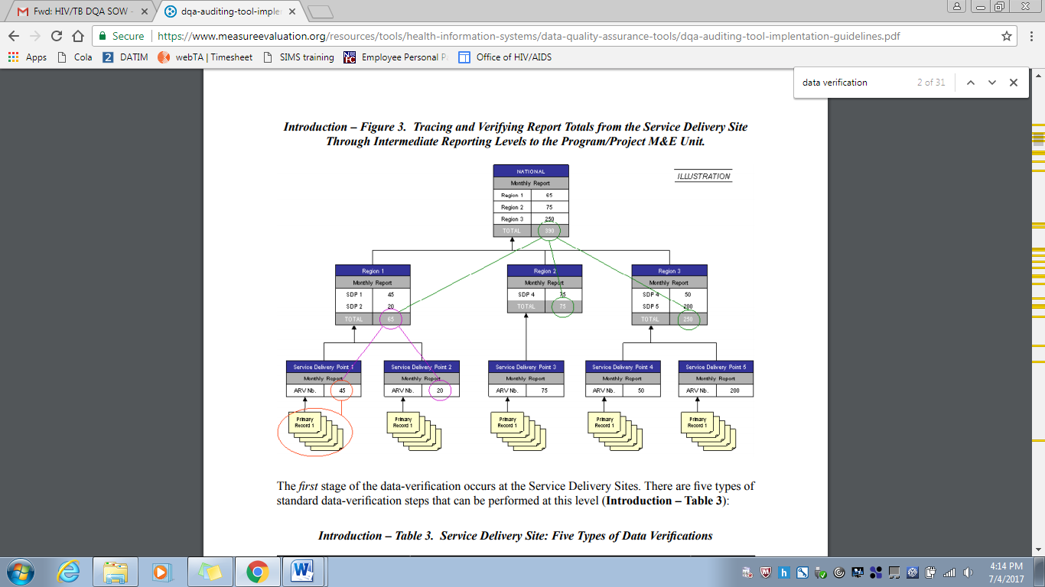

Source: MEASURE Evaluation (2008).

## 8.3 VERIFICATION FACTORS – OVC_SERV LOPIN 1 CENTRAL, STATE AND CBO LEVELS

Table 12. Verification Factors – OVC_SERV at LOPIN 1 Central M&E Unit

|  |  |
| --- | --- |
| Level / Name | LOPIN 1 Central M&E Unit |
| OVC_SERV |  |
| Verified Data | 139,658 |
| Reported Data | 139,658 |
| Verification Factor (%) | 100% |

Table 13. Verification Factors – OVC_SERV at LOPIN 1 State and CBO Levels

|  |  |  |  |  |  |  |
| --- | --- | --- | --- | --- | --- | --- |
| S NO | TYPE OF LEVEL | NAME OF LEVEL | LOCATION OF THE LEVEL | VERIFIED DATA | REPORTED DATA | VERIFICATION FACTOR (%) |
| 1 | State level | LOPIN 1 State Office | Akwa Ibom | 68,427 | 68427 | 100% |
| 2 | State level | LOPIN 1 State Office | Lagos | 37,139 | 36,989 | 100% |
| 3 | State level | LOPIN 1 State Office | Rivers | 34,096 | 34,096 | 100% |
| 4 | CBO | HELIN | Akwa Ibom/Uyo | 12,738 | 12,743 | 100% |
| 5 | CBO | BF | Akwa Ibom/Ikot Ekpene | 12599 | 13429 | 94% |
| 6 | CBO | CF | Lagos/Agege | 9169 | 9169 | 100% |
| 7 | CBO | RHN | Lagos/Ajeromi Ifelodun | 9615 | 9640 | 100% |
| 8 | CBO | AOCF | Lagos/Kosofe | 3657 | 3504 | 104% |
| 9 | CBO | LCIF | Rivers/Eleme | 9097 | 9097 | 100% |
| 10 | CBO | RIDEC | Rivers/Obio Akpor | 12295 | 12295 | 100% |
| 11 | CBO | HCF | Rivers/Port Harcourt | 12704 | 12704 | 100% |

Table 14. OVC_HIVSTAT Numerator Disaggregates at the Central, State and CBO Levels

|  |  |  |  |  |  |  |  |  |  |
| --- | --- | --- | --- | --- | --- | --- | --- | --- | --- |
|  |  | VERIFIED DATA | | | | REPORTED DATA | | | |
| SITE NAME | **STATE/ LGA** | **A: Reported HIV positive to IP** | **B: Reported HIV negative to IP** | **C: No HIV status reported to the IP** | **Total: A+B+C** | **A: Reported HIV positive to IP** | **B: Reported HIV negative to IP** | **C: No HIV status reported to the IP** | **Total: A+B+C** |
| ARFH LOPIN 1 HQ office | Lagos | 329 | 71640 | 25706 | 97,675 | 329 | 71640 | 25706 | 97,675 |
| Akwa Ibom IP State Office | Akwa Ibom | 145 | 34651 | 13858 | 48,654 | 145 | 34651 | 13858 | 48,654 |
| Lagos IP State Office | Lagos | 139 | 23327 | 1109 | 24,575 | 139 | 23327 | 1270 | 24,736 |
| Rivers IP State Office | Rivers | 45 | 13662 | 10473 | 24,180 | 45 | 13662 | 10473 | 24,180 |
| Heal the Land Initiative (HELIN) | Akwa Ibom/Uyo | 13 | 8002 | 2247 | 10,262 | 13 | 8002 | 2252 | 10,267 |
| BROKLINE Foundation | Akwa Ibom/Ikot Ekpene | 18 | 6694 | 2190 | 8,902 | 18 | 6694 | 2553 | 9,265 |
| Chamagne Foundation | Lagos/Agege | 33 | 6022 | 0 | 6,012 | 33 | 6055 | 0 | 6,088 |
| Rhoda Haven Network for Women Living with HIV/AIDS (RHODA HAVEN) | Lagos/Ajeromi Ifelodun | 50 | 6285 | 0 | 6,335 | 50 | 6285 | 0 | 6,335 |
| Arms of Comfort Foundation (AOCF) | Lagos/Kosofe | 3 | 2360 | 0 | 2,363 | 3 | 2388 | 0 | 2,391 |
| Lifetime Caring International Foundation | Rivers/Eleme | 8 | 4063 | 2196 | 6,267 | 8 | 4063 | 2196 | 6,267 |
| Rhemacare Integrated Development Centre (RIDEC) | Rivers/Obio Akpor | 11 | 4371 | 4514 | 8,896 | 11 | 4371 | 4514 | 8,896 |
| Hope and Care Foundation | Rivers/Port Harcourt | 23 | 5139 | 3855 | 9,017 | 23 | 5139 | 3855 | 9,017 |

Table 15. Verification Factors of OVC_HIVSTAT Numerator Disaggregates at the Central, State and CBO Levels

|  |  |  |  |  |  |
| --- | --- | --- | --- | --- | --- |
|  |  | VERIFICATION FACTORS | | | |
| SITE NAME | **STATE/ LGA** | **A: Reported HIV positive to IP** | **B: Reported HIV negative to IP** | **C: No HIV status reported to the IP** | **Total** |
| ARFH LOPIN 1 HQ office | Lagos | 100% | 100% | 100% | 100% |
| Akwa Ibom IP State Office | Akwa Ibom | 100% | 100% | 100% | 100% |
| Lagos IP State Office | Lagos | 100% | 100% | 87% | 99% |
| Rivers IP State Office | Rivers | 100% | 100% | 100% | 100% |
| Heal the Land Initiative (HELIN) | Akwa Ibom/Uyo | 100% | 100% | 100% | 100% |
| BROKLINE Foundation | Akwa Ibom/Ikot Ekpene | 100% | 100% | 86% | 96% |
| Chamagne Foundation | Lagos/Agege | 100% | 99% | 100% | 99% |
| Rhoda Haven Network for Women Living with HIV/AIDS (RHODA HAVEN) | Lagos/Ajeromi Ifelodun | 100% | 100% | 100% | 100% |
| Arms of Comfort Foundation (AOCF) | Lagos/Kosofe | 100% | 99% | 99% | 99% |
| Lifetime Caring International Foundation | Rivers/Eleme | 100% | 100% | 100% | 100% |
| Rhemacare Integrated Development Centre (RIDEC) | Rivers/Obio Akpor | 100% | 100% | 100% | 100% |
| Hope and Care Foundation | Rivers/Port Harcourt | 100% | 100% | 100% | 100% |

## 8.5 DIAGRAMMATIC REPRESENTATION OF CROSS-CHECKS AT CBO LEVEL

*Figure 13. Methodology for Cross-Checks at CBO Level*

**OVC CROSS CHECK AT CBO**

CROSS CHECK 1

CROSS CHECK 2

Select 10 Enrollment numbers and unique identifiers within the Reporting Period from NOMIS

Select 10 Beneficiary Service Forms (randomly where feasible) within the Reporting Period from 10 Folders (Using Enrollment Number and Unique Identifiers)

Confirm enrollees in NOMIS have 10 corresponding service forms

Confirm 10 enrollees are present on the NOMIS

Trace and Find Corresponding Entries and Compare in the NOMIS

Trace and Find Corresponding Entries and Compare in the Service Forms

## 8.6 DATA BACKUP MECHANISMS IN AKWA IBOM STATE CBOs

Table 16. Backup Mechanisms Utilized in Akwa Ibom State CBOs Visited

|  |  |  |  |  |  |  |  |  |  |  |  |
| --- | --- | --- | --- | --- | --- | --- | --- | --- | --- | --- | --- |
| Name of CBO | Backup Mechanism Utilized | | | | | | | |  |  | Timeline |
| **Cloud Based** | | | | **Hard Drive** | **Flash Drive** | **Official Laptops** | **Personal devices** | **C. drive** | **E-Mail** |  |
| Unspecified | OneDrive | Google Drive | Drop Box |  |  |  |  |  |  |  |
| HELIN |  |  |  |  | √ |  |  |  |  |  | Monthly |
| BF |  |  |  |  | √ |  |  |  |  | √ | Monthly |

## 8.7 DATA BACKUP MECHANISMS IN LAGOS STATE CBOS

Table 17. Backup Mechanisms Utilized in Lagos State CBOs Visited

|  |  |  |  |  |  |  |  |  |  |  |
| --- | --- | --- | --- | --- | --- | --- | --- | --- | --- | --- |
| Name of CBO | Backup Mechanism Utilized | | | | | | | |  | Timeline |
| **Cloud Based** | | | | **Hard Drive** | **Flash Drive** | **Official Laptops** | **Personal devices** | **E-mails** |  |
| Unspecified | One Drive | Google Drive | Drop Box |  |  |  |  |  |  |
| CF | **√** |  |  |  | **√** |  |  |  | **√** | Weekly |
| RHN |  |  |  |  | √ |  |  |  | √ | Weekly and Monthly |
| AOCF | **√** |  |  |  | **√** |  |  |  | **√** | Monthly |

## 8.8.DATA BACKUP MECHANISMS IN RIVERS STATE CBOs

Table 18. Backup Mechanisms Utilized in Rivers State CBOs Visited

|  |  |  |  |  |  |  |  |  |  |
| --- | --- | --- | --- | --- | --- | --- | --- | --- | --- |
| Name of CBO | Backup Mechanism Utilized | | | | | | | | Timeline |
| **Cloud Based** | | | | **Hard Drive** | **Flash Drive** | **Official Laptops** | **Personal devices** |  |
| Unspecified | One Drive | Google Drive | Drop Box |  |  |  |  |  |
| LCIF | √ |  |  |  | √ |  |  |  |  |
| RIDEC | **√** |  |  |  | **√** |  |  |  | Monthly |
| HCF | √ |  |  |  | √ |  |  |  | Fortnightly |

## 8.9 PERFORMANCE INDICATOR REFERENCE SHEET (PIRS)

Table 19: Performance Indicator Reference Sheet for OVC_SERV

|  |  |  |  |  |  |
| --- | --- | --- | --- | --- | --- |
| |  | | --- | | **OVC_SERV** | | | | | |
| Description: | Number of beneficiaries served by PEPFAR OVC programs for children and families affected by HIV | | | |
| Numerator: | Number of beneficiaries served by PEPFAR OVC programs for children and families affected by HIV | | The numerator is the sum of the following Program participation disaggregation:  1. Active beneficiaries  2. Graduated beneficiaries | |
| |  | | --- | | Denominator: | | N/A | | | |
| Changes in indicator: | Clarifying language added to this indicator reference sheet. Only OVC that actually received services in the past three months should be counted in this indicator. OVC that have registered for the program but have not yet received any services should not be counted in the results (MER 2.0 v2.1 to v2.2).  The disaggregation for program participation status has been clarified to capture types of beneficiaries: (1) active beneficiaries and (2) graduated beneficiaries, (MER 2.0 v2.2 Revised Release).  Beneficiaries that transferred or exited without graduation should no longer be reported in the numerator (MER 2.0 v2.2 Revised Release). However, these data will still be collected as disaggregates.  All indicator changes will be reflected in the data entry screens in DATIM beginning in FY 18 Q2 (MER 2.0 v2.2 Revised Release).  The transferred disaggregation was split into two separate disaggregation’s: transferred out to a PEPFAR-supported partner and transferred out to non-PEPFAR supported partner (MER 2.0 v2.2 Revised Release).  Indicator calculation is updated. Indicator returns to being a snapshot indicator again for FY 18 reporting. Results should not be summed across reporting periods (MER 2.0 v 2.2 Revised Release). | | | |
| How to use: | PEPFAR is mandated to care for children orphaned or made vulnerable by HIV. Mitigating the impact that HIV is having on children and the families that support them is integral to a comprehensive HIV response. It is important to note that the definition of “affected” children includes, but is not limited to, children infected with HIV. PEPFAR recognizes that individuals, families, and communities are affected by HIV in ways that may hinder the medical outcomes of HIV-positive persons as well as the emotional and physical development of children orphaned or made vulnerable by HIV/AIDS. A variety of services (per Technical Considerations 2017) are supported through PEPFAR to mitigate these effects in order to improve health and well-being outcomes of adults and children. The goal of OVC programs is to build stability and resiliency in children and families-exposed, living with or affected by HIV/AIDS through rigorous case management and provision and access to health and socio-economic interventions. This indicator, by disaggregating “active” and “graduated” in the numerator and collecting additional disaggregates for “transferred out to a PEPFAR-supported partner”, “transferred out to a non-PEPFAR supported partner”, and “exited without graduation” measures how successful the OVC program is in building children and their families’ resiliency. | | | |
| How to collect: | The data sources are the PEPFAR OVC program registers and program data generated by implementing partners. Implementing partners’ registers need to record names of children and caregivers who meet the criteria for “active beneficiary” or “graduated” to generate the numerator total included in this indicator. In addition, implementing partners should record whether children or caregivers “transferred out to a PEPFAR-supported partner”, “transferred out to a non-PEPFAR supported partner”, and “exited without graduation.”  All agencies receiving HKID funding are required to report on this indicator.  This indicator is a direct (output) measure of the number of individuals receiving PEPFAR OVC program services for children and families affected by HIV/AIDS and tracks progress on the number of OVC graduating from PEPFAR OVC programs and tracks “exited without graduation” (such as loss-to-follow up, aging out without transition plan, moved, or died). Transferred to existing host-country programs, where the host-country program provides a sustainable response to OVC needs. Transferred to existing PEPFAR-supported programs to track movement of children and caregivers between PEPFAR-supported partners. Graduation will vary based on local criteria for achieving stability in the household. | | | |
| Reporting level: | Facility & Community | | | |
| How often to report: | Semi-Annual | | | |
| How to review for data quality: | Reviewing PEPFAR OVC implementing partners’ results to ensure that there is no double counting and changes by Program Completion Status do not show high deviations from program targets and/or SNU prioritization (scale up, sustained, centrally supported, sustained commodities.  To ensure completeness, check that OVC_SERV total numerator (auto calculated based on participation status disaggregates) equals OVC_SERV results by age/sex disaggregates:  • OVC_SERV total numerator should equal OVC_SERV <1 + 1-9 + 10-14F + 10-14M + 15-17F + 15-17M + 18-24F + 18-24 M + 25+F + 25+M  • OVC_SERV total numerator should equal OVC_SERV<18 + OVC_SERV 18+  • OVC_SERV<18 = OVC_SERV <1 + 1-9 + 10-14F + 10-14M + 15-17F + 15-17M  • OVC_SERV 18+ = OVC_SERV 18-24F + 18-24 M + 25+F + 25+M | | | |
| How to calculate annual total: | To calculate data for annual results for OVC_SERV:  Sum Active (children and caregivers received services in the past three months) + Graduated (OVC that graduated from the OVC program in the past 12 months).  This indicator should be reported as a snapshot (i.e., report data as of the last day of the reporting period) in DATIM. | | | |
| Data elements (components of indicator): | Numerator:  Number of beneficiaries served by PEPFAR OVC programs for children and families affected by HIV. | Disaggregate Groups | | Disaggregates |
| Program Participation Status  [Required] | | * Active (Received at least one service in the past 3 months) * Graduated (At Q2: Report children and parents/ caregivers that graduated from the OVC program in the past 6 months. At Q4: Report children and parents/ caregivers that graduated from the OVC program in the past 12 months.) |
| Age/Sex (For Active and Graduated)  [Required]  Exited or Transferred [Required] Disaggregate should be reported for exited or transferred, even if no numerator (active + graduated) values are reported. | | * <1, 1-9, 10-14 M, 10-14 F, 15-17 M, 15-17 F, 18-24 M, 18-24 F, 25+ M, 25+ F * Transferred out to a PEPFAR-supported partner (At Q2: Report children and parents/caregivers that transferred out to a PEPFAR-supported partner in the past 6 months. At Q4: Report children and parents/caregivers that transferred out to a PEPFAR supported partner in the past 12 months.) * Transferred out to a non-PEPFAR supported partner (At Q2: Report children and parents/caregivers that transferred out to a non-PEPFAR-supported partner in the past 6 months. At Q4: Report children and parents/caregivers that transferred out to a non-PEPFAR supported partner in the past 12 months.) * Exited without graduation (At Q2: Report children and parents/caregivers that exited in the past 6 months. At Q4: Report children and parents/caregivers that exited in the past 12 months.) |
|  |  | Age/Sex/OVC Service Area  [DREAMS Conditional] | | * Education Support: <1, 1-9, 10-14 M, 10-14 F, 15-17 M, 15-17 F, 18-24 M, 18-24 F, 25+ M, 25+ F * Parenting/Caregiver Support: <1, 1-9, 10-14 M, 10-14 F, 15-17 M, 15-17 F, 18-24 M, 18-24 F, 25+ M, 25+ F * Social Protection: <1, 1-9, 10-14 M, 10-14 F, 15-17 M, 15-17 F, 18-24 M, 18-24 F, 25+ M, 25+ F * Economic Strengthening: <1, 1-9, 10-14 M, 10-14 F, 15-17 M, 15-17 F, 18-24 M, 18-24 F, 25+ M, 25+ F * Other Service Areas: <1, 1-9, 10-14 M, 10-14 F, 15-17 M, 15-17 F, 18-24 M, 18-24 F, 25+ M, 25+ F |
|  | Disaggregate Descriptions & Definitions | | | |
|  | Program Participation Status Definitions:   * “Active beneficiary” is an individual, a child, or parent/caregiver who has received at least one PEPFAR OVC program service in the last three months. New beneficiaries registered during the reporting period can be counted as active only if they have received at least one service in the last three months. Assessment, enrolment, case plan development, and case plan monitoring are not considered services. Please refer to the forthcoming OVC Reporting FAQ clarification on what activities constitute a service for more information. * “Graduation” is defined as:   1. Graduation is defined as happens when children and parent/caregivers enrolled in PEPFAR OVC programs are deemed stable and no longer in urgent need of externally supported services. Criteria for achieving stability in the household vary and should be defined at the OU-level to be consistent across IPs.  Or  2. Aging out: This only includes children who have reached the age of 18 and who have a transition plan for successful exiting from the PEPFAR OVC Program. This does not apply to children > 18 years old enrolled in secondary education.  Exited or Transferred Disaggregate Definitions:   * “Transferred out to a non-PEPFAR-supported partner” happens when children and families have transitioned to other forms of support programs other than PEPFAR funded OVC programs. These could include country-led programs or other donor funded programs. * “Transferred out to a PEPFAR-supported partner” happens when children and families have transitioned from the support of one PEPFAR partner to another PEPFAR-partner. * “Exited without graduation” This includes children and caregivers who are lost-to-follow up, re-located, or died and children who aged-out without a graduation plan from PEPFAR OVC program. | | | |
| PEPFAR-support definition: | Standard definition of DSD and TA-SDI used.  Provision of key staff or commodities for OVC beneficiaries receiving care and support services in the community include: For beneficiaries of OVC services, this can include funding of salaries (partial or full) for staff of the organization delivering the individual, small group or community level activity (e.g., psychosocial support, child protection services, education, etc.) or procurement of critical commodities essential for ongoing service delivery. Partial salary support may include stipends or incentives for volunteers or paying for transportation of those staff to the point of service delivery.  For care and support services, ongoing support for OVC service delivery for improvement includes: the development of activity-related curricula, education materials, etc., supportive supervision of volunteers, support for setting quality standards and/or ethical guidelines, and monitoring visits to assess the quality of the activity, including a home visit, a visit to a school to verify a child’s attendance and progress in school or observation of a child’s participation in kids clubs. | | | |
| Guiding narrative questions: | 1. What is the total achievement of OVC_SERV for <18 years and total numerator? Please explain partners with highest/lowest performance.  2. Please explain results by participation status disaggregate:  a. What criteria do beneficiaries need to achieve in order to graduate? Is that standard across partners in your OU?  b. How many beneficiaries exited without graduation? Please explain the reasons for exiting without graduation and try to quantify with percentages if possible. Are there certain partners with higher rates of exiting without graduation? How are you managing this with the partner(s)?  c. How many beneficiaries were transitioned? To whom (e.g., other NGOs, government support, etc.). Where were beneficiaries transferred? Please provide disaggregates for beneficiaries transferred to specific sources of support.  d. Of those who are reported to be active, what percentage is newly enrolled? Any re-enrollments of those LTFU? If yes, how many? Are any partners especially good at finding and re-enrolling those LTFU? | | | |

Table 20: Performance Indicator Reference Sheet for OVC_HIVSTAT

|  |  |  |  |  |
| --- | --- | --- | --- | --- |
| **OVC_HIVSTAT** | | | | |
| Description: | Percentage of orphans and vulnerable children (<18 years old) with HIV status reported to implementing partner (including report of no status). | | | |
| Numerator: | Number of orphans and vulnerable children (<18 years old) with HIV status reported to implementing partner, disaggregated by status type. | | Data sources for this indicator include HIV test results that are self-reported by OVC (or their caregivers), results of HIV Risk Assessments conducted by implementing partners, registers, referral forms, client records, or other confidential case management and program monitoring tools that track those in treatment and care. | |
| Denominator: | Number of orphans and vulnerable children reported under OVC_SERV (<18 years old) | | Denominator is not collected again, as part of this indicator but is collected under the indicator OVC_SERV. | |
| Changes in indicator: | • This indicator formerly called OVC_ACC (MER 1.0) and OVC_KNOWNSTAT (in the original MER 2.0 target setting documentation guidance) was changed to OVC_HIVSTAT to reflect that HIV status is self- reported to the implementing partner by the OVC or OVC caregiver (MER 1.0 to MER 2.0). | | | |
| How to use: | |  | | --- | | This indicator will be tracked through routine program monitoring semi- annually through the POART process.  Given the elevated risk of HIV infection among children affected by and vulnerable to HIV, it is imperative for PEPFAR implementing partners to monitor HIV status among OVC beneficiaries, and to facilitate access and retention in ART treatment for those who are HIV positive. When the implementing partner knows the HIV status, the program can contribute to ensuring that the children are linked to appropriate care and treatment services, all essential elements of quality case management. OVC programs can also play an important role in family-centered disclosure, for those who are HIV positive.  • This indicator is NOT intended to be an indicator of HIV tests performed or receipt of testing results, as these are measured elsewhere and test results are frequently unavailable to community organizations due to health facility concerns about patient confidentiality.  • This indicator is NOT intended to imply that all OVC beneficiaries require an HIV test. OVC with known positive or negative status do not need to be tested. Only OVC with no HIV status or children reported to be negative and recently experiencing sexual violence and/or other risk factors in the reporting period should be assessed for HIV risk. For older children who the IP thinks may be sexually active, they should be assessed every reporting period.  • Status disclosure to the implementing partner is NOT a prerequisite for enrollment or continuation in an OVC program. OVC programs serve persons of positive, negative, and unknown HIV status appropriate to their needs and vulnerability to HIV. This indicator ensures that IPs are regularly providing outreach to caregivers to identify children’s HIV status, encourage family disclosure and linkage to care and treatment as needed.  • This indicator captures if implementing partners are tracking the self-reported HIV status of the orphans and vulnerable children they serve and enrollment in ART for those who are positive. Testing results for OVC who are referred for testing should be reported under HTS_TST based on the service delivery point where they were tested  This indicator also captures if implementing partners are tracking if the orphans and vulnerable children they serve who report to be HIV positive are successfully linked to and retained in treatment and care.  • This indicator is a subset from OVC_SERV. Only OVC who were reported under OVC_SERV <18 should be included in the denominator for this indicator.  • Since this is not a testing indicator, HIV positivity yield should NOT be calculated based on this indicator. Yield calculations should only be made by testing partners. | | | | |
| How to collect: | Data sources for this indicator include HIV test results that are self-reported by OVC (or their caregivers), results of HIV Risk Assessments conducted by implementing partners, registers, referral forms, client records, or other confidential case management and program monitoring tools that track those in treatment and care.  Implementation of the HIV risk assessment should be integrated into case management and on-going case monitoring and should not be conducted separately, if possible. This will vary by partner and project. The partners should work out a timeline based on their experience of how long referral completion and status disclosure usually takes and factor that into their case management processes.  Implementing partners will record the OVC beneficiary’s self-reported HIV status –semi-annually. | | | |
| Reporting level: | Facility & Community | | | |
| How often to report: | Semi-Annual | | | |
| How to review for data quality: | The OVC_HIVSTAT total numerator should ideally equal OVC_SERV<18 results. In some cases, there may be missing data for the following reasons: 1) IP was not able to collect this information from all caregivers of OVC_SERV<18 within the reporting period, 2) IP was not able to locate all the caregivers of OVC_SERV<18 (e.g., relocated, migrant work), 3) data entry error and/or 4) Peace Corps is currently not reporting on this indicator so OVC served <18 under PC would be missing.  Review any site with the following reporting issues: 1) numerator greater than 100% of OVC_SERV <age 18, 2) very low coverage of OVC_HIVSTAT, 3) sum of “Currently on ART” and “Not currently on ART” do no equal the “Reported HIV positive to IP” results and 5) sum of “Test not indicated” and “Other reasons” do not equal “Reported No Status to IP”. | | | |
| How to calculate annual total: | Use result reported at Q4. | | | |
| Data elements (components of indicator): | Numerator:  Number of orphans and vulnerable children (<18 years old) with HIV status reported to implementing partner, disaggregated by status type. | Disaggregate Groups | | Disaggregates |
| Status Type  [Required] | | • Reported HIV positive to implementing partner  o Currently receiving ART  o Not currently receiving ART  • Reported HIV negative to implementing partner  • No HIV status reported to the implementing partner  o Test not indicated based on HIV risk assessment  o Other reasons |
| Disaggregate Descriptions & Definitions | | | |
| Status Type Disaggregate Definitions:  “Reported HIV Positive to IP”: includes beneficiaries <age 18 who report to the IP that they are HIV positive based on an HIV test conducted during or prior to the reporting period (regardless of where the test occurred). All entries for “reported HIV positive to IP” should be further disaggregated as “currently receiving ART” or “not currently receiving ART.” This also includes beneficiaries <age 18 who report that they are HIV positive based on an HIV test conducted during previous project reporting periods. OVC entered as “Reported HIV positive to IP” in the previous reporting period, should continue to be reported as positive during the current reporting period and their enrollment in ART noted.  • “Reported HIV negative to IP” includes beneficiaries <age 18 who report that they are HIV negative to the IP based on an HIV test conducted during the reporting period (regardless of where the test occurred). For a child who reports multiple tests within the current period, use most recent test. For beneficiaries entered as “Reported HIV negative to IP” in a previous reporting period—if the IP believes the child’s risk has not changed in the last six months, they should continue to report the child as negative during the current reporting period. However, if the IP believes that the child has recently been exposed to risk of HIV infection (e.g., sexual violence) or if an adolescent has become sexually active, then the IP should conduct the HIV risk assessment. Potential outcomes reported after the HIV risk assessment include 1) the child is tested and reported as HIV positive and either currently receiving ART or not receiving ART, or 2) the child is tested and reported as HIV negative, or 3) the child is reported as “No Status” and under one of its disaggregates (“Test not indicated” or “Other reasons”).  • “No HIV status reported to the IP” includes beneficiaries who fall into one of the below described categories:  • “Test not indicated” – includes beneficiaries (OVC_SERV<age 18) who based on a risk assessment made by the implementing partner do not require a test during the reporting period. (Consensus Conference Technical Report on the Role of OVC Programs Supported by PEPFAR in Extending Access to HTS includes further information on determining whether a test is indicated)  • “Other reasons” – includes all beneficiaries (OVC_SERV <age 18) not entered in above categories. Potential scenarios included in other reasons include:  i. Caregiver refuses to disclose whether the child has been tested and his/her current HIV status in the reporting period  ii. Caregiver refuses to let the IP conduct a risk assessment on the child in the reporting period.  iii. Caregiver recommended by IP to have child tested base on risk assessment, but refuses to test the child in the reporting period OR does take child to test but doesn't report results to IP in the reporting period.  iv. The IP is still in the process of convincing the caregiver to get the child assessed, tested and/or disclosure of status. Since this is a new indicator and takes time, IPs may not be positioned to report within the reporting period and would be captured under – Undisclosed to IP - Other Reasons. The IP should monitor these children and provide services to encourage referral completion and disclosure in the next reporting period.  • Children entered as “No HIV status reported to the IP” with the disaggregate “Other reasons” in the previous reporting period should receive follow-up services to encourage referral completion/disclosure of status to the IP. Children reported as “No HIV Status to the IP” with the disaggregate “Test not indicated” with no changes in their risk situation for past six months, don’t need to be reassessed. If the IP believes the child’s risk situation has changed in the last six months, then the child should be reassessed by the implementing partner to determine whether testing is indicated and the results entered as outline above, and the child should receive appropriate follow-up | | | |
| PEPFAR-support definition: | Standard definition of DSD and TA-SDI used.  Provision of key staff or commodities for OVC beneficiaries receiving care and support services in the community include: For beneficiaries of OVC services, this can include funding of salaries (partial or full) for staff of the organization delivering the individual, small group or community level activity (e.g., psychosocial support, child protection services, education, etc.) or procurement of critical commodities essential for ongoing service delivery. Partial salary support may include stipends or incentives for volunteers, or paying for transportation of those staff to the point of service delivery.  For care and support services, ongoing support for OVC service delivery for improvement includes: the development of activity-related curricula, education materials, etc., supportive supervision of volunteers, support for setting quality standards and/or ethical guidelines, and monitoring visits to assess the quality of the activity, including a home visit, a visit to a school to verify a child’s attendance and progress in school or observation of a child’s participation in kids clubs. | | | |
| Guiding narrative questions: | For OVC_HIVSTAT, if less than 100% of caregivers have reported their child's status, please explain the percentage that have not reported to the IP their child's status and the plan to get closer to 100% coverage. Are there certain partners that are struggling and how the Mission is responding?  2. For children reported as not currently on ART, what are efforts are being undertaken in response? Are there certain partners with low ART coverage, why?  3. Please explain the breakdown of those reported under No Status. What percentage were: 1) risk assessed and reported as test not indicated and 2) test indicated, 3) caregivers unwilling to disclose status; 4) incomplete referrals for testing; 5) Other reasons (please specify). | | | |

## 8.10 LIST OF DOCUMENTS, DATA, AND STANDARD OPERATING PROCEDURES REVIEWED

### 8.10.1 LIST OF LOPIN 1 DATA AND DOCUMENTS REVIEWED

1. LOPIN 1 CBO indicator data submissions
2. LOPIN 1 state report submissions
3. LOPIN 1 FY18 semi-annual OVC data – October 2017-March 2018

### 8.10.2 LIST OF LOPIN 1 REPORTING TOOLS REVIEWED

1. VC Enrollment Register
2. VC Enrollment Form
3. OVC Service Form
4. Child Follow Up Assessment Form

### 8.10.3 LOPIN 1 SOP/GUIDELINES AND OTHER DOCUMENTS REVIEWED

1. Performance Indicator Reference Sheet (PIRS)
2. M&E Training Reports
3. ARFH SOP for Data Management Final Submission

## 8.11LIST OF INDIVIDUALS INTERVIEWED DURING THE LOPIN 1 DQA

Note: For full form of CBO acronyms, please refer to the acronym list on page 1.

Table 21. List of Individuals Interviewed during the LOPIN 1 DQA

|  |  |  |  |  |  |
| --- | --- | --- | --- | --- | --- |
| S. No. | Name | Location | Title | State | Level |
| 1 | Afolabi Bamigboye | ARFH-LOPIN 1 | Dr M&E | Oyo | National |
| 2. | Osinowo Kunle | ARFH/LOPIN 1 | M&E Officer | Oyo | National |
| 3 | Gbenga Ashaolu | ARFH/LOPIN 1 | Snr M&E | Oyo | National |
| 4 | Olaitan Yemisi | ARFH/LOPIN I LAGOS | State Program Advisor | Lagos | State |
| 5 | Osinwo Kunle | ARFH/LOPIN I LAGOS | M&E Officer | Lagos | State |
| 6 | Ogunmodede M. | ARFH/LOPIN I LAGOS | TASD | Lagos | State |
| 7 | Theresa Uwaleke | ARFH/LOPIN I LAGOS | Program Monitor | Lagos | State |
| 8 | Kolawole Abdullahi | ARFH/LOPIN I LAGOS | Program Monitor | Lagos | State |
| 9 | Adenaube Ranmilowo | ARFH/LOPIN I LAGOS | Program Monitor | Lagos | State |
| 10 | Ogundare Ebenezer | ARFH/LOPIN I LAGOS | Program Manager | Lagos | State |
| 11 | Salau Dauda .A. | Chamagne foundation | File Manager | Lagos | CBO |
| 12 | Hassan Yusuf | Chamagne foundation | M&E Officer | Lagos | CBO |
| 13 | Alabi Adekemi | Chamagne Foundation | Program Coordinator | Lagos | CBO |
| 14 | Ojosipe Abimbola | Chamagne Foundation | Executive Director | Lagos | CBO |
| 15 | Daini Oluwakemi | Chamagne Foundation | Assistant Program Officer | Lagos | CBO |
| 16 | Oyebanjo Yetunde | Chamagne Foundation | M&E Officer | Lagos | CBO |
| 17 | Adeniyi Lateef | Chamagne Foundation | Assistant M&E Officer | Lagos | CBO |
| 18 | Owosho Olufunmitela | Chamagne Foundation | Program Officer | Lagos | CBO |
| 19 | Ihemenam Joseph | Rhoda’s Haven | Program Officer | Lagos | CBO |
| 20 | Mhrih Jones | Rhoda’s Haven | Executive Director | Lagos | CBO |
| 21 | Opunnika O.D | Rhoda’s Haven | M&E Officer | Lagos | CBO |
| 22 | Sekinat Williams | Rhoda’s Haven | Assistant M&E Officer | Lagos | CBO |
| 23 | Godwin Akpan | Rhoda’s Haven | Assistant Program Officer | Lagos | CBO |
| 24 | Florence Emmanuel | Rhoda’s Haven | Finance Officer | Lagos | CBO |
| 25 | Ademola Blessing | Rhoda’s Haven | Office Assistant | Lagos | CBO |
| 26 | Abiodun Adekemi | Rhoda’s Haven | File Manager/ Admin Assistant | Lagos | CBO |
| 27 | Sam- Adeboye K.R | Arms of Comfort Foundation | Executive Director | Lagos | CBO |
| 28 | Ebulu John | Arms of Comfort Foundation | Assistant M&E Officer | Lagos | CBO |
| 29 | Adeniyi Azeez | Arms of Comfort Foundation | M&E Officer | Lagos | CBO |
| 30 | Lemeke Flourish | Arms of Comfort Foundation | M&E Manager | Lagos | CBO |
| 31 | Michael Ejeh | ARFH-LOPIN1 Akwa Ibom | State Program Coordinator | Akwa Ibom | State |
| 32 | Somoton Olashem | ARFH-LOPIN1 Akwa Ibom | M&E officer | Akwa Ibom | State |
| 33 | Benjamin Ezra | ARFH-LOPIN1 Akwa Ibom | Program Assistant | Akwa Ibom | State |
| 34 | Ezeoba Augusta | ARFH-LOPIN1 Akwa Ibom | FDO | Akwa Ibom | State |
| 35 | Tony Nwaehiri | ARFH-LOPIN1 Akwa Ibom | Finance Officer | Akwa Ibom | State |
| 36 | Idowu Olawale | ARFH-LOPIN1 Akwa Ibom | Corp Member | Akwa Ibom | State |
| 37 | Uduak Jackson | ARFH-LOPIN1 Akwa Ibom | Assistant Technical Officer | Akwa Ibom | State |
| 38 | Kehinde Opeka | ARFH-LOPIN1 Akwa Ibom | Program Manager (PM) | Akwa Ibom | State |
| 39 | Ibok Ekemini Sunday | ARFH-LOPIN1 Akwa Ibom | Program monitor | Akwa Ibom | State |
| 40 | Idowu Olawale J. | ARFH-LOPIN1 Akwa Ibom | Corp member | Akwa Ibom | State |
| 41 | Mbuofidem Markson | HELIN | Assistant Program Officer | Akwa Ibom | CBO |
| 42 | Jessica Charles | HELIN | Program Officer | Akwa Ibom | CBO |
| 43 | Akudo Nwgu | HELIN | Executive Director | Akwa Ibom | CBO |
| 44 | Mfon Umoren | HELIN | Asst. M&E officer | Akwa Ibom | CBO |
| 45 | Okezie Bright | HELIN | M&E Officer | Akwa Ibom | CBO |
| 46 | Uduak Ime | HELIN | M&E Assistant | Akwa Ibom | CBO |
| 47 | David Ekong | HELIN | File/Admin | Akwa Ibom | CBO |
| 48 | Edidiong Udobong | BF | M&E officer, BF | Akwa Ibom | CBO |
| 49 | Andrew Sudo | BF | Asst. M&E Officer, BF | Akwa Ibom | CBO |
| 50 | Ekong Ndifeke Udo | BF | Program Officer Essien Udim | Akwa Ibom | CBO |
| 51 | Raphael Raphael Joshua | BF | M&E Essien Udim | Akwa Ibom | CBO |
| 52 | Uko Victor Ekanem | BF | Assistant Program Officer | Akwa Ibom | CBO |
| 53 | Felicia Aloysius Enang | BF | Assistant Finance Manager | Akwa Ibom | CBO |
| 54 | Hon. Edemekong Aniefiok | BF | Finance Officer | Akwa Ibom | CBO |
| 55 | Isaac Davies | BF | Executive Director | Akwa Ibom | CBO |
| 56 | Ojewumi Titus K | ARFH Rivers | M&E | Rivers | State |
| 57 | Onuorah Ada | ARFH Rivers | Prog. Assos. For Household Econ. Strength | Rivers | State |
| 58 | Fubara Adiebome | ARFH Rivers | SPC | Rivers | State |
| 59 | Oladimeji Olakunle | ARFH Rivers | Finance Officer | Rivers | State |
| 60 | Olumide Taiwo | ARFH Rivers | Front Desk Officer | Rivers | State |
| 61 | Ogonna Abraham | ARFH Rivers | Program Manager | Rivers | State |
| 62 | Prince B. Lebari | LTCIF | M&E Officer | Rivers | CBO |
| 63 | Pretty Abaadan | LTCIF | M&E Assistant | Rivers | CBO |
| 64 | Jim Evelyn | LTCIF | Program Assistant | Rivers | CBO |
| 65 | Mbonu C Juliet | LTCIF | Admin/ Filling | Rivers | CBO |
| 66 | Kabari M. Thankgod | LTCIF | Executive Director | Rivers | CBO |
| 67 | Kaave T. Jacob | LTCIF | Program Officer | Rivers | CBO |
| 68 | Kelechi Okoroji | RIDEC | Executive Director | Rivers | CBO |
| 69 | Olalemi Adewumi | RIDEC | Program Monitor | Rivers | CBO |
| 70 | Joy Nwokpo | RIDEC | Program Officer | Rivers | CBO |
| 71 | Taiwo Oloruntosin | RIDEC | Program Officer | Rivers | CBO |
| 72 | Ezeugo Chima | RIDEC | M&E Officer | Rivers | CBO |
| 73 | Adebiyi Yusuf | RIDEC | Finance &Admin Manager | Rivers | CBO |
| 74 | Ndujiechi Gloria | RIDEC | APO/HESFP | Rivers | CBO |
| 75 | Oguche Janet Ene | RIDEC | Assist M&E | Rivers | CBO |
| 76 | Victoria Madumere Ndukwe | HCF | CEO | Rivers | CBO |
| 77 | Amadi Emmanuel | HCF | Project Coordinator | Rivers | CBO |
| 78 | Favour Kalu Offar | HCF | Finance Officer | Rivers | CBO |
| 79 | Thankgod Onita | HCF | M&E Assistant | Rivers | CBO |
| 80 | Amadi Victor Chidi | HCF | M&E Assistant | Rivers | CBO |
| 81 | Nwude Afam | HCF | Program Officer | Rivers | CBO |
| 82 | Queenmary Johnson A. | HCF | Program Assist. Officer | Rivers | CBO |
| 83 | Babema-Igonikon A. R | HCF | M&E Officer | Rivers | CBO |
| 84 | Mere Chioma | HCF | Program Monitor | Rivers | CBO |
| 85 | Worgu Kenneth N. | HCF | Program Monitor | Rivers | CBO |

1. MEASURE Evaluation. Data Quality Assurance Tools: DQA and RDQA Toolkit (Internet). Available from: <https://www.measureevaluation.org/resources/tools/health-information-systems/data-quality-assurance-tools>
2. ADS 201 Additional Help. USAID Recommended Data Quality Assessment (DQA) Checklist. Available from: <https://www.usaid.gov/sites/default/files/documents/1865/201sae.pdf>
3. MEASURE Evaluation. Data Quality Assurance Tools: DQA and RDQA Toolkit (Internet). Available from: https://www.measureevaluation.org/resources/tools/health-information-systems/data-quality-assurance-tools
4. ADS 201 Additional Help. USAID Recommended Data Quality Assessment (DQA) Checklist. Available from: <https://www.usaid.gov/sites/default/files/documents/1865/201sae.pdf>
5. USAID. How-To Note: Conduct a Data Quality Assessment [Internet]. 2017. Available from: https://usaidlearninglab.org/sites/default/files/resource/files/cleared_-_how-to_note_-_conduct_a_dqa.pdf
6. MEASURE Evaluation. Data Quality Audit Tool: Guidelines for Implementation [Internet]. 2008. Available from: <https://www.measureevaluation.org/resources/publications/ms-08-29>